Standards Process

The "standards process" is the set of steps involved in modifying the PDS Standards Reference (PDSSR) and, by implication, the tools, other software, and the data system that it governs. The scope of the "standards process" includes modifications to the Planetary Science Data Dictionary Document (PSDDD) and its associated files.

The "standards process" involves the Standards Coordinator, a member of the Engineering Node (EN) staff assigned to maintain the integrity of the Standards and oversee the change process; the PDS Technical Group (TG); and ad hoc working groups established to flesh out, debug, and evaluate Standards Change Requests (SCRs). The evolution of an SCR is described succinctly by its "status" (Appendix A).

Step 1. The SCR is the vehicle by which standards changes are requested, refined, approved (or rejected), and implemented (if approved). An SCR may be submitted by anyone having access to
http://pds-engineering.jpl.nasa.gov/index.cfm?pid=2&cid=55
The originator completes at least the required fields in the form (Appendix B) and receives an acknowledgement, including the SCR tracking number. The system providing the acknowledgement simultaneously (within one working day) posts the SCR, opens a blog for comment, and notifies the Standards Coordinator of its submission. At this point, the SCR status is initialized to SUBMITTED.

Step 2. The Standards Coordinator reviews the SCR's initial priority, then recruits a Working Group (WG) to refine the SCR and appoints one of its members as chair. The ideal Working Group includes proponents, skeptics, representatives from disciplines which would be most affected, and technical experts who can identify impacts within PDS, impacts on external interfaces, and inconsistencies with other standards (ODL, ISO, etc.). When the ideal Working Group cannot be recruited, the Standards Coordinator appoints volunteers who are simply interested or willing to serve. The size and composition of the Working Group should be matched to the difficulty of the expected task. Once the Working Group has been established, the Standards Coordinator sets the SCR status to IN_DRAFT. If a Working Group cannot be recruited, the Standards Coordinator sets the SCR status to PARKED and attempts to recruit a Working Group at some later time.

Step 3. The task of the Working Group is to refine the SCR so that it meets the goals of the originator while being consistent with the constraints of PDS. The SCR form (Appendix B) should be fleshed out to include a brief history of the Working Group deliberations, the need being addressed, any relevant background information including urgency in making the change, one or more proposed solutions (including verbatim text changes, if any, which can be inserted into PDS documents), and an impact assessment. The impact assessment must include what work will be needed and an estimate of the resources required. The impact assessment must include indirect impacts — for example, changes at Discipline Nodes required to accommodate an SCR that is written entirely in terms of "central" operations. If the Working Group determines that the impact is low, it may recommend that the SCR be implemented after approval by only the Technical Group. Once a draft suitable for review by the TG has been completed, it is delivered to the Standards Coordinator who will schedule discussion and set the SCR status to IN_REVIEW. If the Working Group is unable to reach agreement or concludes that the SCR is not in the best interests of PDS or the planetary community, the chair notifies the Standards Coordinator who, if there are no ideas for resolving the impasse, restarts the process at Step 2 and resets the SCR status to SUBMITTED. The WG (including the Standards Coordinator, acting as a "Working Group of one") may also forward the SCR to the TG with a negative recommendation.

Step 4. After discussion — which can include blog, e-mail, telecon, and face-to-face components — the Technical Group takes one of four possible actions:

(a) approves the SCR and forwards it to the Management Council for final approval (SCR status set to ENDORSED)
(b) gives conditional approval to a "low impact" SCR (SCR status set to TG_APPROVED)
(c) rejects the SCR and refers it back to the Working Group (SCR status is reset to IN_DRAFT) (return to Step 3)
(d) rejects the SCR outright (SCR status is set to REJECTED)

TG approval (a or b) requires a favorable vote by a majority of those eligible to vote. The vote consists of one vote per node, cast by individuals who are designated by their respective node managers; the Radio Science Advisor is also entitled to a vote. Outright rejection (d) requires a majority vote of those eligible to vote. If one or more votes is conducted and none of these results obtains, the default action is referral back to the Working Group (c).

Step 5. If the SCR is ENDORSED or TG_APPROVED, the Standards Coordinator reports the action to the Program Scientist and the Management Council. If ENDORSED, a Management Council vote is required. If TG_APPROVED, any single voting member of the Management Council may request a formal vote on the SCR (at which point the SCR status is reset to ENDORSED); if there is no such request within 10 working days, the SCR status is automatically reset to APPROVED. In the Management Council at least six "yes" votes are required for approval, of which at least four must be from "science" nodes. The Program Scientist reports the result of any vote to the Standards Coordinator; if the vote is favorable, the SCR status is set to APPROVED. An SCR that fails to be approved in a Management Council vote is returned to the TG for disposition (returns to Step 4 with SCR status reset to IN_REVIEW). At its discretion, the Management Council may offer suggestions or recommendations on how the TG should proceed.

Step 6. SCRs with status APPROVED are assigned to the Engineering Node for implementation, which does so using its normal procedures for change in a configuration controlled environment. Data providers may include the approved SCR features in archive design and production, but should be alert to subtleties of implementation that may not be apparent from the SCR itself. When the SCR is fully implemented (changes to the PDSSR, PSDDD, Archive Preparation Guide, Proposer's Archiving Guide, other documents, associated files, and tools have been completed and released for public use), the Standards Coordinator sets SCR status to IMPLEMENTED.

The Standards Coordinator advises the originator, the Working Group, and the Technical Group of changes in SCR status.
A

ppendix A. SCR Status and Meanings

SUBMITTED | An SCR has been submitted, the required minimum fields have been completed, and the system has issued an SCR tracking number. The Standards Coordinator is (or soon will be) in the process of appointing a Working Group to refine the SCR.
PARKED | The Standards Coordinator was unable to recruit a Working Group, or an earlier Working Group could not reach consensus on a proposal. The Standards Coordinator will periodically seek to set up a new Working Group. NB: The Standards Coordinator has the option of appointing him/herself as a Working Group of one and forwarding the SCR to the Technical Group with a negative recommendation, in hopes of getting a REJECTED vote and clearing a bad proposal from the system.
IN_DRAFT | The Working Group is fleshing out the SCR, resolving conflicts, identifying impacts, and estimating resources needed to address the impacts.
IN_REVIEW | A draft SCR, suitable for review by the Technical Group, has been completed and forwarded to the Technical Group for review.
ENDORSED | The Technical Group has approved the SCR and forwarded it to the Management Council for final approval.
TG_APPROVED | The SCR has been approved by the Technical Group and its impact has been judged "low." The Management Council has been advised of this action. If one member of the Management Council requests a vote within 10 working days, status is reset to ENDORSED. If not, status is set to APPROVED after the 10 day waiting period.
APPROVED | The Technical Group has approved the SCR, and Management Council has not chosen explicitly within 10 working days to conduct its own vote; or the Management Council has voted favorably on the SCR. In either case, the SCR is in the hands of EN for implementation, which may be in progress. Data providers may use the provisions of the SCR but should be alert to subtleties of implementation which may not be apparent from the SCR itself.
REJECTED | The SCR was rejected by the Technical Group and will not be the subject of further discussion or action. A possible end state. NB: Rejection does not preclude resubmission.
IMPLEMENTED | The SCR has been fully implemented. Changes to the PDSSR, PSDDD, Archive Preparation Guide, Proposer's Archiving Guide, other documents, associated files, and tools have been completed and released for public use. A possible end state.
Appendix B. Integrated Web-Based Submission Form and SCR Template

The following information is needed for each Standards Change Request. Some of it should be entered at the time the SCR is submitted. The original information will be revised and supplemented as the SCR evolves. In the following, REQUIRED indicates those fields which must be completed during initial submission through the web interface.

Title (REQUIRED): a terse (less than 64 character) identifier that summarizes the proposal/issue and distinguishes it from other titles in the SCR queue.

Submission Date (NOT VISIBLE ON WEB FORM): Filled in by the web-based system.

Submitter (REQUIRED): Name of the person filling out the web form.

E-Mail (REQUIRED): E-mail address of the Submitter.

History (NOT VISIBLE ON THE WEB FORM; to be maintained by the Standards Coordinator as the SCR moves through the system): What happened at each step, when, and by whom? Include terse summaries of issues raised, including reasons for "no" votes, if those occur.

Problem (REQUIRED): A statement of the problem and its immediate consequences. Is there an error in the PDSSR? Is something ambiguous? Is something needed to address a situation which was not previously anticipated? Is this a request for a new PDS feature or service?

Milestones (OPTIONAL): Who needs this, when, and why? Do the consequences become more severe if there is delay?

Immediacy (OPTIONAL): Should this change be implemented now, or would it be appropriate to wait (until PDS4, for example)? A "radio" button with choices: PDS3, PDS4, or NO OPINION.

Proposed Solution (REQUIRED): Outline your proposed solution, including changes to PDS standards, the Data Dictionary, and/or other documents. "Unknown" is an acceptable answer.

Impact Assessment (OPTIONAL): What will need to be changed if this request is approved, and what will be the resources needed to implement it? Include impacts on the core system; discipline, data, and sub-nodes; and any implications for other systems. If not sure, list possible impacts that should be investigated by the Working Group. As a minimum, every SCR presented to the Technical Group must have each item in the following list addressed. If a particular item is not affected, state "no impact." Identify the assessor in each case.
PDS Standards Reference
Planetary Science Data Dictionary Document
PDS Tools
intra-Node, PDS-wide
legacy, in development, proposed
PDS web site, product servers, profile servers
other PDS documents (e.g., PAG, APG)
external agencies (e.g., NSSDC, ESA, IPDA)
external interfaces (e.g., NSSDC, ADS)
compliance/compatibility with ODL and ISO standards

Priority (OPTIONAL): Should this be (1) worked immediately, (2) accelerated, (3) allowed to flow through at "normal" speed, or (4) placed on the back burner? The priority will be reviewed at each step in the process based on urgency, past experience, and competing proposals.

Recommended Approval Authority (NOT VISIBLE ON WEB FORM): The Working Group and/or the Technical Group may recommend for or against a formal vote by the Management Council; or they may say nothing.

Working Group (OPTIONAL): Recommend people or DNs that would likely be interested in serving on the Working Group. The actual Working Group will be appointed by the Standards Coordinator.

Additional Information (OPTIONAL): List any external references with relevant information.

Dependencies/Contingencies (OPTIONAL): List in detail any dependencies or contingencies that might need to be addressed either in parallel or in advance of implementation (for example, does this SCR depend on another SCR?).

Requested Changes (OPTIONAL): List specific changes requested in detail, such as exact wording to be replaced in documents, full definitions of new elements, etc.

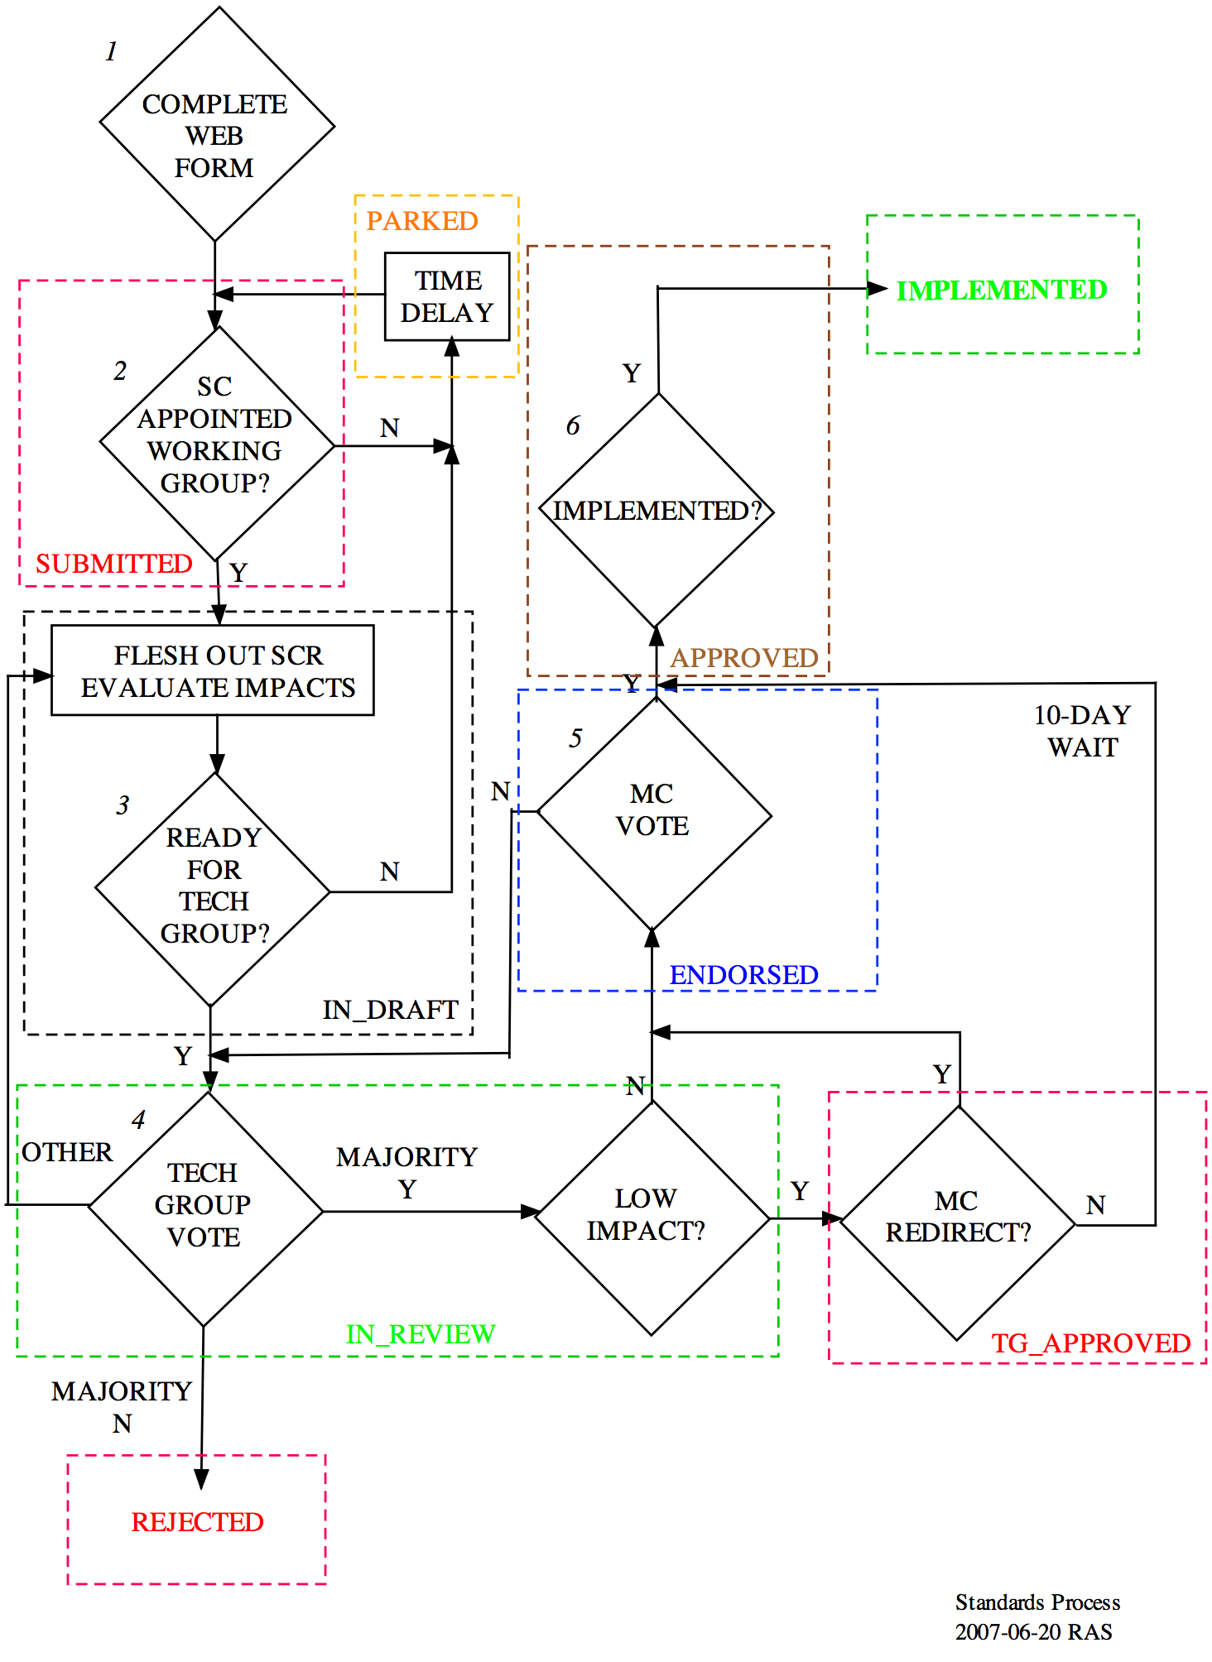
Standards Process
Frequently Asked Questions (FAQs)

Q1. Why can SCRs be submitted only through a restricted web site?

A1. The SCR process is internal to PDS; it is not something that can be initiated by members of the general public. EN recommended, and MC quickly concurred, early in 2007 to add password control to internal PDS web pages -- to protect against increasing levels of abuse from hackers and spammers. Members of the public can always contact a DN (the preferred route for most PDS questions) to request that an SCR be submitted; the DN can then provide some initial filtering on the request and ensure that the submission meets minimum requirements. Use of the web site (rather than or in addition to paper, which has been the traditional mode) simplifies ingestion, tracking, and management of SCRs.

Q2. Does the Standards Coordinator chair Technical Group sessions?

A2. That is up to the Engineering Node. There are certainly instances where having the SC as chair would facilitate discussions; but the TG is charged with broader responsibilities than handling SCRs, and there may be others at EN who would be more appropriate as chair for those discussions. In fact, EN appoints THREE people who have roles in the Technical Group: the TG Chair, the SC, and the EN voting representative. These can all be different people, the appointments can change from meeting to meeting, and (in principle) they could change within a single meeting.

Q3. Why can't I withdraw an SCR if I change my mind?

A3. Once the "submit" button is pressed at the SCR web site, the request becomes the responsibility of the Standards Coordinator -- who may begin work on it immediately. If the Submitter has a change of heart, the simplest recourse would be to contact the SC personally and request the "withdrawal." If the SC agrees, then the SC can forward the SCR to the TG with a negative recommendation and it can be REJECTED very quickly. The Submitter always has the option of resubmitting if the "withdrawn" SCR was based on errors or misunderstandings and if an issue still remains. But the SC may see other issues beyond what the Submitter imagined and may prefer to let the SCR run its course; the TG could have a similar reaction. There is also a timing question; if the SCR were in the implementation stage, could the Submitter still withdraw it? So, once the SCR is in the system, it no longer "belongs" to the Submitter and cannot be removed unilaterally.

Q4. Why are the "science" and "support" node definitions not spelled out in the discussion of MC voting?

A4. MC has already defined "science" and "support" nodes and how they are counted in its own procedure for e-mail voting. The Standards Process document only adopts those definitions and extends them to ALL voting that concerns SCRs. It would be inappropriate and confusing to define the same terms in different documents, especially if MC decides some day to change them (for example, by recognizing a new DN).

Q5. Why is the time period for an SCR vote at the MC open ended?

A5. Several ideas were proposed during discussion of the Standards Process document to ensure that SCRs didn't get bogged down at the MC approval step. Most of these led to a default decision if MC failed to act within a specified amount of time (assuming that the SCR had very little interest to MC). The general consensus was that having explicit decisions made at each step was preferable to mistakenly forwarding a proposal with the wrong implicit decision. There are no specific time limits imposed at other stages in an SCR's life cycle, so the unlimited time allowed for an MC vote is consistent.

Q6. When can I start "using" an SCR?

A6. PDS recognizes that completing all steps in order for an SCR to be IMPLEMENTED takes time -- especially if documents or tools must be revised and re-released. The CONCEPTS embedded in an SCR can be used in archive design and creation as soon as the SCR reaches the APPROVED stage. But data providers who choose to take advantage of the SCR as soon as it is APPROVED should check back later to make sure that tools behave as expected and that there are no unexpected "notes" in the documents. Occasionally some "fine tuning" is needed to complete an implementation and two readers of the SCR may anticipate the results differently. Rather than cause a new round of SCR's to be spawned to handle the "fine tuning," PDS gives EN some latitude during the implementation stage; it is ultimately up to the data provider to conform to the result which is IMPLEMENTED.

