Planetary Data System

PDS Mirror Site Standby Mode Test
Procedures

April 16, 2006

Version 0.060416

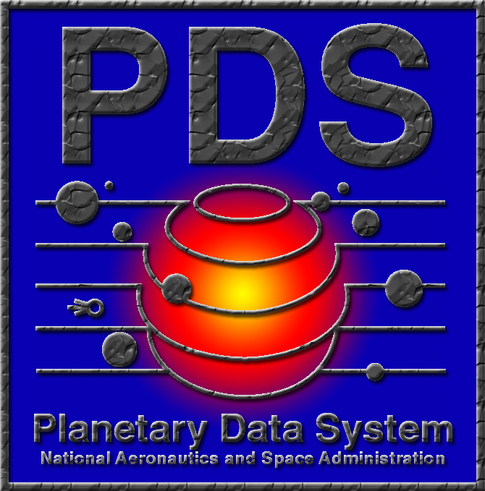


Jet Propulsion Laboratory
Pasadena, California

Change Log

Revision | Date | Description | Author
0.060306 | March 06, 2006 | Initial draft. | A. Leung
0.060416 | April 16, 2006 | Format and procedural changes. | A. Leung  E. Law

Table of Contents

1 Introduction 1
1.1 Purpose 1
1.2 Scope 1
1.3 Audience 1
1.4 Applicable Documents 1
2 Test Procedures for PDS Mirror Site Webpage Server 2
2.1 PDS Home Page 2
2.2 Data Services Page 3
2.3 Tools Page 4
2.4 Data Dictionary Lookup Page 5
2.5 Software Download Page 7
2.6 Phone Book Page 8
2.7 Documents Page 9
2.8 Subscription Manager 10
3 Test Procedures for PDS Mirror Site Web Applications Server 12
3.1 Basic Browser 12
3.2 Data Set Status 13
3.3 Data Set Search 13
3.4 PDS Explorer 14
3.5 Resource Manager 15
4 Appendix A 16

Introduction
Since the PDS went operational in March 1990, the PDS Catalog, its interfaces and all supporting applications have been hosted at a single site, now called the Engineering Node (EN). The EN is located at JPL. The deployment in 2002 of PDS-D, the infrastructure that supports electronic distribution of PDS products across the geographically distributed nodes, also has core components which have been installed at the EN. The configuration of these functional components at a single site has been identified as a “single point of failure”. If the EN site becomes inoperable for any reason, several key functional capabilities of the PDS will no longer be available, including the PDS Catalog, PDS Phone Book, and the PDS-D Query Service.

The PDS Core Components Mirror Site provides the capability for the online function of the PDS to continue operating at an acceptable level in the event that the EN infrastructure fails catastrophically.

Purpose
The purpose of this document is to provide test procedures and expected results for verifying the PDS Core Operations Mirror Site.

Scope
This document is scoped to verify the Mirror Site’s online core capabilities running in its standby mode on the PDS webpage server and the PDS-D web application server. Test procedures include:

- PDS webpage server test procedures provide basic information and steps for testing the PDS webpage server which hosts the PDS Home Page, Software Download, Documentations, and Subscription Manager.

- PDS-D web applications server test procedures describe how to verify the functionality and/or interface of all the PDS profile servers and applications/tools including Basic Browser, Data Set Status, Data Set Search, PDS Explorer and Resource Manager.

Audience
This document is written primarily for those who will participate in the testing of the Mirror Site. The expected audience includes:

- PDS Engineering Node (EN) Staff
- PDS Mirror Site Staff

Applicable Documents
[1] Planetary Data System (PDS) Mirror Site Installation Procedures.
[2] Planetary Data System (PDS) Mirror Site Test Plan.

Test Procedures for PDS Mirror Site Webpage Server

PDS Home Page
- In a browser window, enter URL: http://mirpds.astro.umd.edu/ in the navigation tool bar and press the return key. The main PDS Home Page will be displayed in the browser window.
- Expected result: URL: http://mirpds.astro.umd.edu/

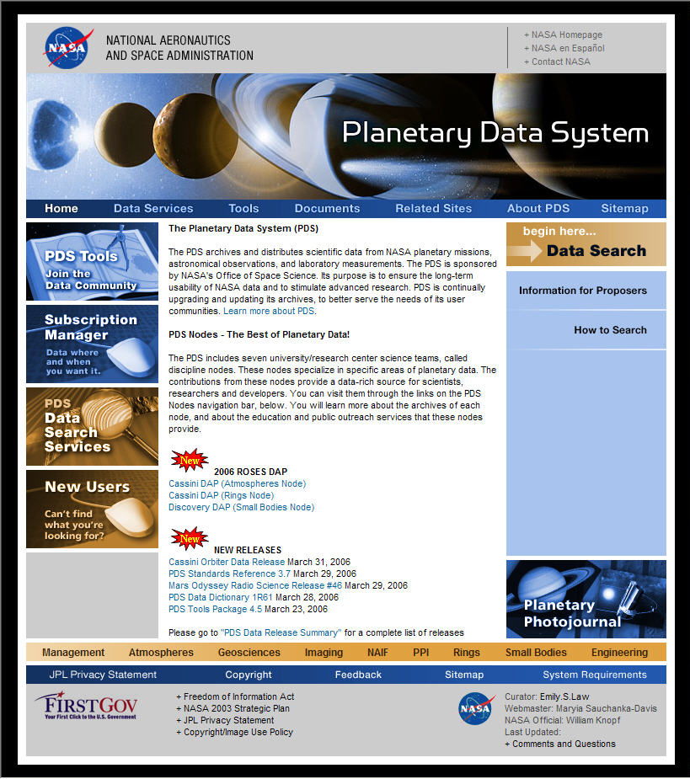

Data Services Page
- Go to PDS Home Page (follow PDS Home Page procedure).
- Click “Data Services” on the top menu bar.
- Expected result: URL: http://mirpds.astro.umd.edu/data_services/
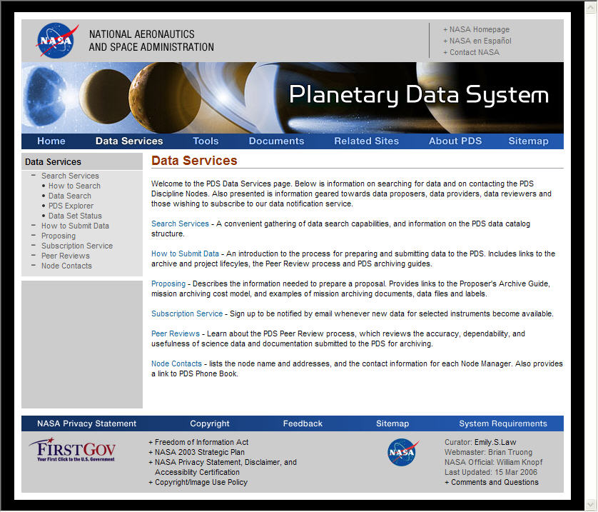

- Click each submenu item on the left-side column under “Data Services”.
- Expected result: Submenu pages will be properly displayed. Below is the list of corresponding URL result pages:

Data Service | URL
Search Services | http://mirpds.astro.umd.edu/data_services/search_services.html
How to search | http://mirpds.astro.umd.edu/data_services/how_to_search.html
Data Search | http://mirbrite.astro.umd.edu/pds/index.jsp
PDS Explorer | http://mirbrite.astro.umd.edu/pds-explorer/index.jsp
Data Set Status | http://mirbrite.astro.umd.edu/dsstatus/
How to submit Data | http://mirpds.astro.umd.edu/data_services/how_to_submit_data.html
Proposing | http://mirpds.astro.umd.edu/data_services/proposing.html
Subscription Service | http://mirpds.astro.umd.edu/subscription_service/top.cfm
Peer Reviews | http://mirpds.astro.umd.edu/data_services/peer_reviews.html
Node Contacts | http://mirpds.astro.umd.edu/data_services/contacts.html

Tools Page
- Go to PDS Home Page (follow PDS Home Page procedure).
- Click “Tools” on the top menu bar.
- Expected result: URL: http://mirpds.astro.umd.edu/tools/

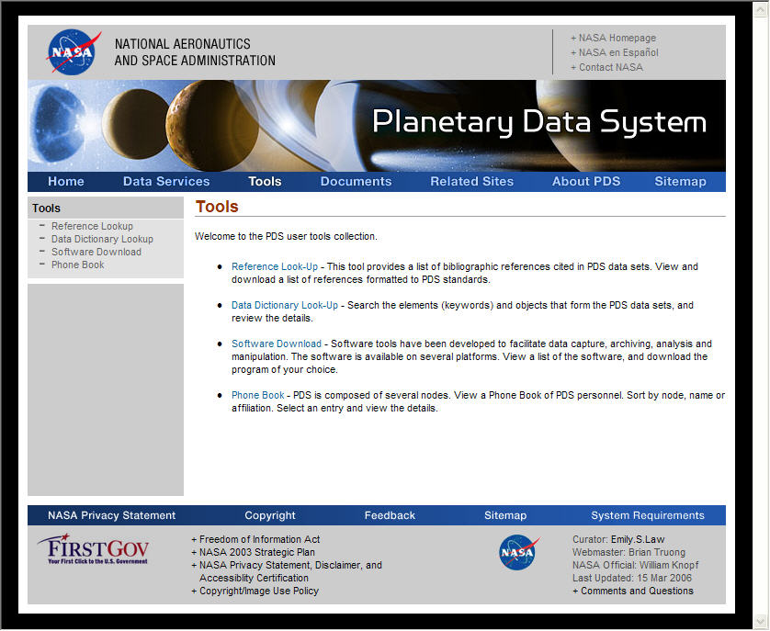

- Click each submenu item on the left-side column under “Tools”.
- Expected result: Submenu web pages will be properly displayed. Below is the list of corresponding URL result pages:

Data Service | URL
Reference Lookup | http://mirpds.astro.umd.edu/tools/reference_lookup.cfm
Data Dictionary Lookup | http://mirpds.astro.umd.edu/tools/data_dictionary_lookup.cfm
Software Download | http://mirpds.astro.umd.edu/tools/software_download.cfm
Phone Book | http://mirpds.astro.umd.edu/tools/phonebook.cfm

Data Dictionary Lookup Page
- Go to Tools Page (follow Tools Page procedure).
- Click “Data Dictionary Lookup” link.
- Expected result: URL: http://mirpds.astro.umd.edu/tools/data_dictionary_lookup.cfm/
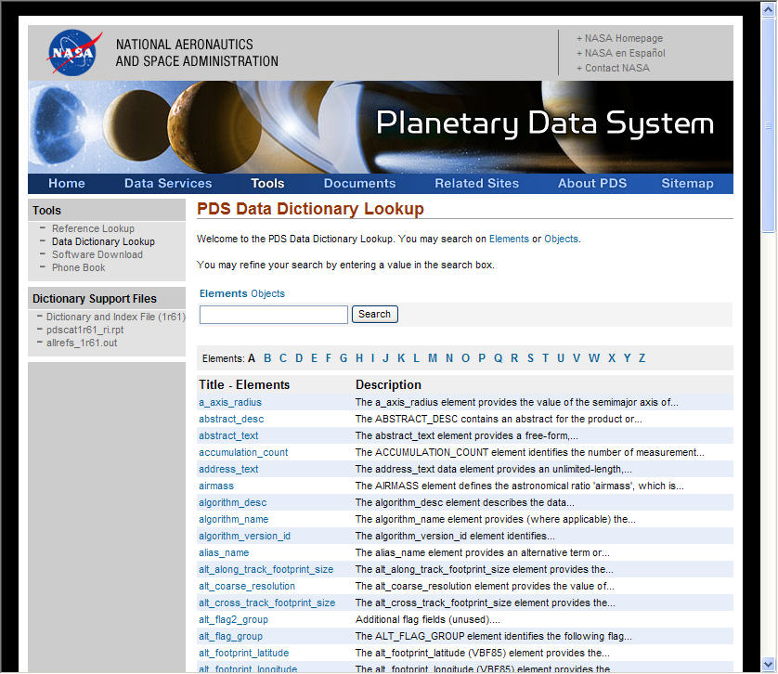
- Click “a_axis_radius”.
- Expected result: Pop up window below.

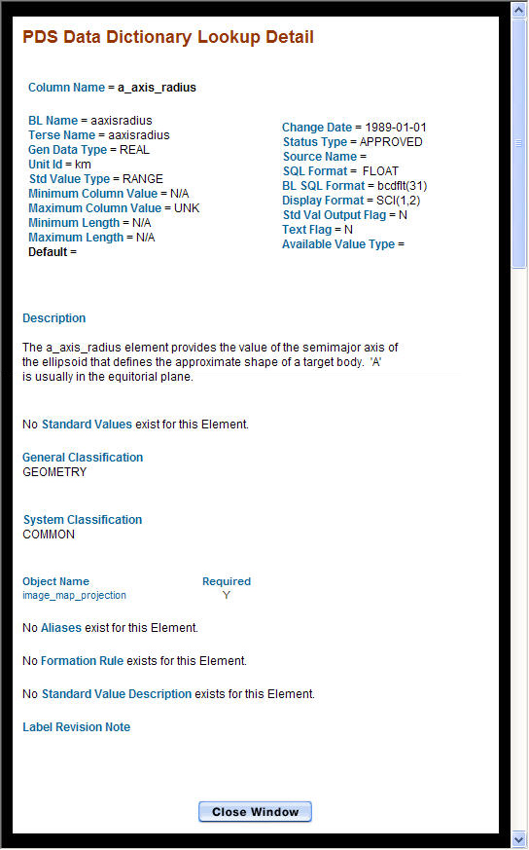

Software Download Page
- Go to Tools Page (follow Tools Page procedure).
- Click “Software Download” link.
- Expected result: URL: http://mirpds.astro.umd.edu/tools/software_download.cfm/
- Select and download a tool.
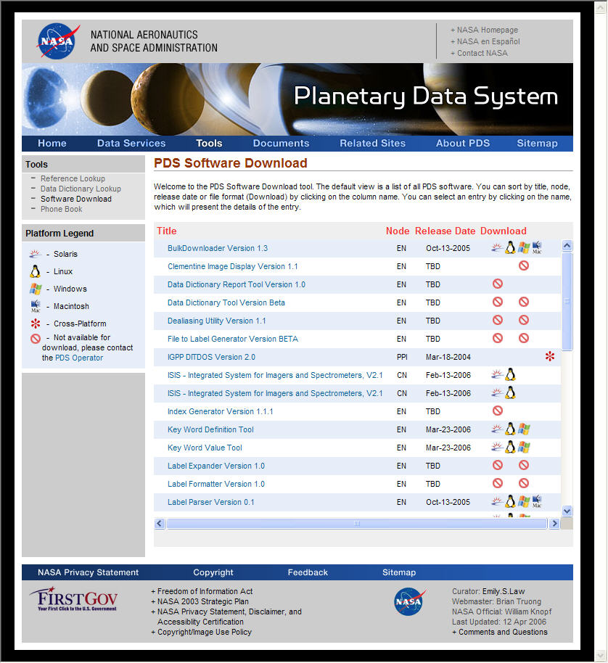

Phone Book Page
- Go to Tools Page (follow Tools Page procedure).
- Click “Phone Book” link.
- Expected result: URL: http://mirpds.astro.umd.edu/tools/phonebook.cfm/
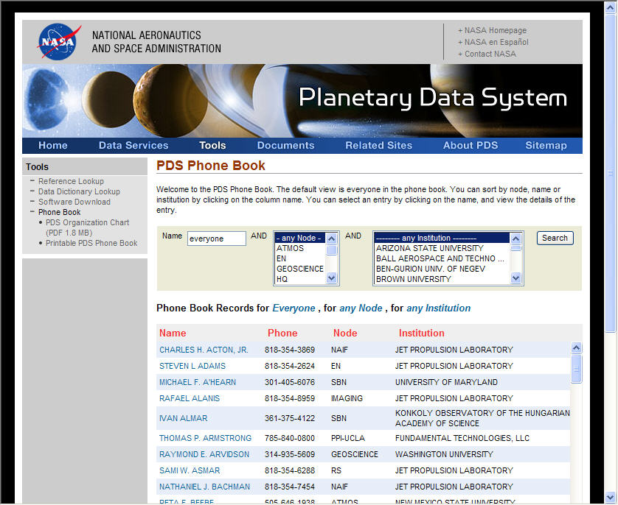

Documents Page
- Go to PDS Home Page (follow PDS Home Page procedure).
- Click “Documents” on the top menu bar.
- Expected result: URL: http://mirpds.astro.umd.edu/documents/

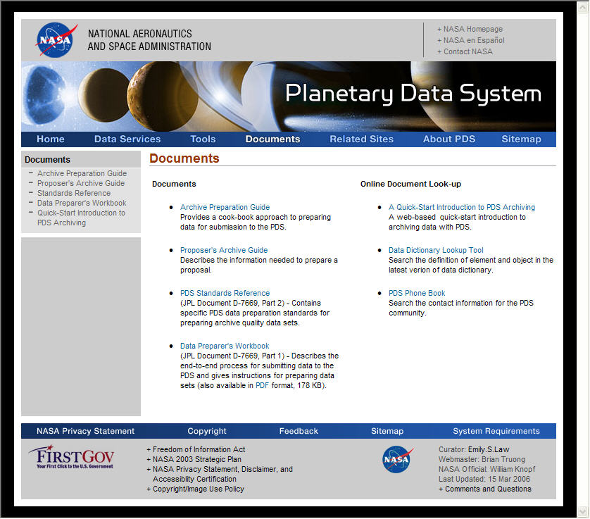
- Click each submenu item on the left-side column under “Documents”.
- Expected result: Submenu web pages will be properly displayed. Below are the list of corresponding URL result pages:
Data Service | URL
Archive Preparation Guide | http://mirpds.astro.umd.edu/documents/apg/index.html
Proposers Archive Guide | http://mirpds.astro.umd.edu/documents/pag/index.html
Standards Reference | http://mirpds.astro.umd.edu/documents/sr/index.html
Digital Preparer's Workbook | http://mirpds.astro.umd.edu/documents/dpw/index.html
Quick Start Introduction to PDS Archiving | http://mirpds.astro.umd.edu/documents/qs/index.html

Subscription Manager
Description
Subscription Manager allows users to register and sign up for e-mail notification when PDS data sets and/or software and/or documentation are updated. The following steps will verify that the interface will be in place for a user to view and make changes to subscription.

Web URL
http://mirpds.astro.umd.edu/subscription_service/top.cfm

Test Steps
- At the PDS Home page http://mirpds.astro.umd.edu , click on the “Subscription Manager” graphic box.
- Expected result: URL: http://mirpds.astro.umd.edu/subscription_service/top.cfm
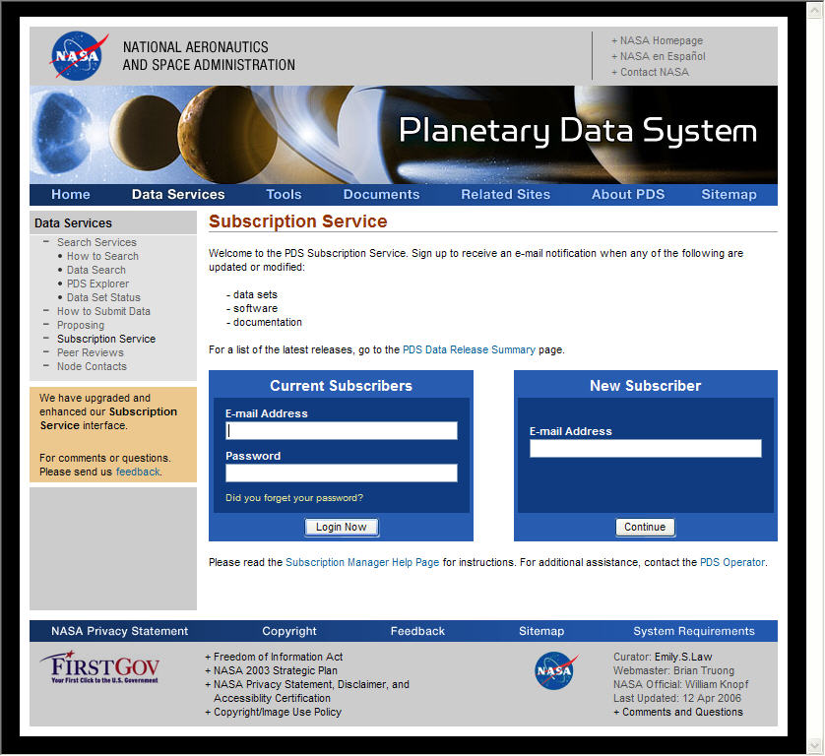
- Log in as JSMITH@jpl.nasa.gov and enter the password new4JSMITH. Note: this user name is case sensitive.
- Expected result: URL: http://mirpds/subscription_service/sm_select_subscriptions.cfm
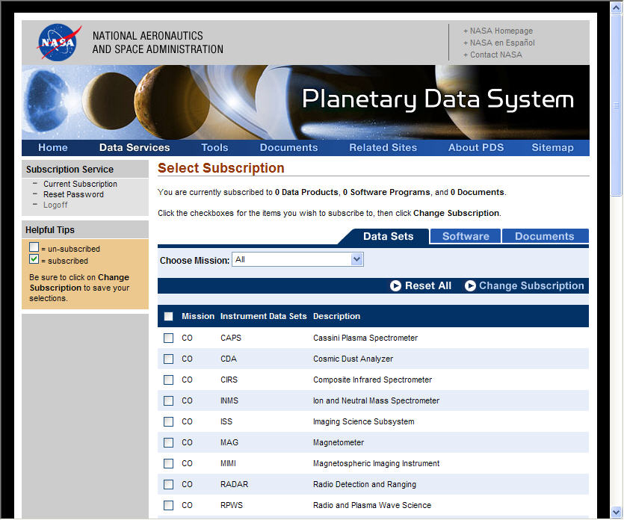
- Click Logoff to exit.

Test Procedures for PDS Mirror Site Web Applications Server

Basic Browser
Description
Basic Browser provides search capability to allow users to perform detailed product searches for named data sets. The search attributes vary by data set.

Web URLs
The following list is a subset of available URLs for performing data product detailed searches provided using Basic Browser.

http://mirbrite.astro.umd.edu/db/servlet/DbSearchServlet?DATA_SET_ID=CO-S/J/E/V-SPICE-6-V1.0
http://mirbrite.astro.umd.edu/db/servlet/DbSearchServlet?DATA_SET_ID=DS1-A/C-SPICE-6-V1.0
http://mirbrite.astro.umd.edu/db/servlet/DbSearchServlet?DATA_SET_ID=MER1-M-SPICE-6-V1.0
http://mirbrite.astro.umd.edu/db/servlet/DbSearchServlet?DATA_SET_ID=MER2-M-SPICE-6-V1.0
http://mirbrite.astro.umd.edu/db/servlet/DbSearchServlet?DATA_SET_ID=MGS-M-ACCEL-2-EDR-V1.1
http://mirbrite.astro.umd.edu/db/servlet/DbSearchServlet?DATA_SET_ID=NEAR-A-MSI-2-EDR-CRUISE1-V1.0
http://mirbrite.astro.umd.edu/db/servlet/DbSearchServlet?DATA_SET_ID=ODY-M-SPICE-6-V1.0
http://mirbrite.astro.umd.edu/db/servlet/DbSearchServlet?DATA_SET_ID=SDU-C-SPICE-6-V1.0

Test Steps
- Go to any of the above links, a Basic Browser search page is displayed.
- Click Go at the top right-hand corner of the search page, a list of results will be displayed in tabular format with one product per entry.
- Click “View Label” under the “Information” column, the PDS label for the particular product will be displayed.
- If there’s an error about service unavailable at step 2, or an error occurred when clicking “View Label” at step 3, contact the PDS EN System Administrator.

Names of product servers serving data products for the above test cases are listed in Appendix A.

Data Set Status
Description
Data Set Status is a reporting tool for users to customize data set status reports containing attributes such as archive status, instrument name, mission name, and PDS node ID.

Web URL
http://mirbrite.astro.umd.edu/dsstatus

Test Steps
- At the PDS Home page http://mirpds.astro.umd.edu , click Data Services at the menu bar, and choose Data Set Status at the left side bar.
- The “Data Set Status” front page will be displayed.
- Click “Submit Query”, a page entitled “Data Set Status Report” will be displayed with “Data Set Id” and “Archive Status” in tabular format.

Data Set Search
Description
Data Set Search provides a way to search the data sets and products by selecting various parameters on one of the three search modes - quick, power, and advanced. The search result lists primary and/or (optional) secondary resources for users to further perform detailed level searches. It also lists metadata about mission, instrument, instrument host, target information related to each data set.

Web URL
http://mirbrite.astro.umd.edu/pds

Test Steps
- At the PDS Home Page http://mirpds.astro.umd.edu , click the “begin here … Data Search” graphic box, the first page of “Data Set Quick Search” will be displayed.
- Highlight one mission name and click “Go!”, a list of search result will be returned.
- Click “View Information” under “Information About the Data Set”, a page with “Citation”, “Data Set Abstract”, and links to additional information is displayed.
- Choose the links for “Mission Information”, “Instrument Host Information”, “Instrument Information”, and “Target Information” and verify the associated information is retrieved.

PDS Explorer
Description
PDS Explorer is a tool to browse and navigate data set online volumes. A listing of data sets can be grouped by Planets and Moons/Targets, Missions, Instruments, or Node Names.

Web URL
http://mirbrite.astro.umd.edu/pds-explorer

Test Steps
- At the PDS Home page http://mirpds.astro.umd.edu , click “Data Services” at the top menu bar, and click PDS Explorer at the left side bar, the first page of PDS Explorer will be displayed with two columns listed as “PLANETS AND MOONS” and “DATA SET ID”.
- Choose the “Node Collection” tab. Click ATMOSPHERES, and click CO-J-CIRS-2/3/4-TSDR-V1.0. A list of Volumes will be listed.
- If any errors occurred in this step, contact the PDS EN System Administrator.
- The following is a list of example data sets with online volumes for testing:

Node Name | Data Set ID
ATMOSPHERE | CO-J-CIRS-2/3/4-TSDR-V1.0
GEOSCIENCES | ODY-M-RSS-1-RAW-V1.0
IMAGING | MER1-M-DESCAM-2-EDR-OPS-V1.0
NAIF | CO-S/J/E/V-SPICE-6-V1.0
PPI | VG1-J-CRS-5-SUMM-FLUX-V1.0
RINGS | HST-S-WFPC2-3-RPX-V1.0
SMALL BODIES | DI/EAR-C-KECK1LWS-3-9P-IMAGES-PHOT-V1.0

Resource Manager
Description
Resource Manager is an administration tool for PDS data providers to manage data set resources in the PDS Catalog database. A new resource can be created through this tool by using existing templates. The editing updates will go directly to the PDS Catalog.

Web URL
http://mirbrite.astro.umd.edu/catalog_tools

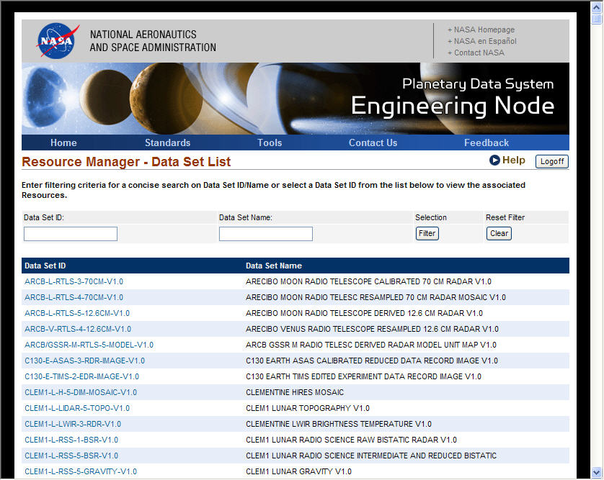

Test Steps
This tool provides a function to modify a resource. The function will not be tested here. The following steps are to ensure that the interface will be in place for data providers.

- At the PDS Home page http://mirpds.astro.umd.edu , select “Engineering” from the node bar at the bottom of the page.
- At the Engineering Node front page, choose “Catalog Tools” on the left side bar and click “Resource Manager”.
- Log in as JSMITH, using the password new4JSMITH. Note: this user name is case sensitive.
- A page with the heading of “Resource Manager – Data Set List” will be displayed with Data Set ID and Data Set Name listed.
- Click Logoff to exit.

Appendix A

Data Set ID | Product Server
CO-S/J/E/V-SPICE-6-V1.0 | PDS.NAIF.Product
DS1-A/C-SPICE-6-V1.0 | PDS.NAIF.Product
MER1-M-SPICE-6-V1.0 | PDS.NAIF.Product
MER2-M-SPICE-6-V1.0 | PDS.NAIF.Product
MGS-M-ACCEL-2-EDR-V1.1 | PDS.Atmos.Product
NEAR-A-MSI-2-EDR-CRUISE1-V1.0 | PDS.CN.Product
ODY-M-RSS-1-RAW-V1.0 | PDS.Geo.Product
SDU-C-SPICE-6-V1.0 | PDS.NAIF.Product

