PDS On-Line System Core Components Mirror Site

Background and Requirements

October 31, 2005

Version 0.051031

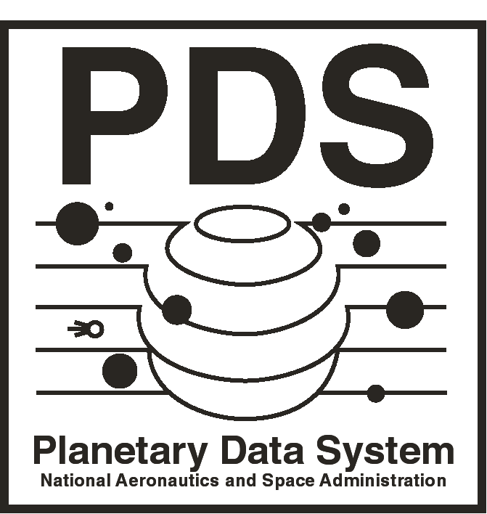



Jet Propulsion Laboratory
Pasadena, California

JPL D-xxxxx

PDS On-Line System Core Components Mirror Site

Background and Requirements

October 31, 2005

Version 0.051031

Approved:

_______________________________________ ______________
Dan Crichton Date
PDS EN Manager

_______________________________________ ______________
J. Steven Hughes Date
PDS EN Systems Engineer

Jet Propulsion Laboratory
Pasadena, California

JPL D-xxxxx
CHANGE LOG

Revision | Date | Description | Author
Start Document | 2005-10-24 | Initial document | S. Hughes
First Update | 2005-10-25 | Updates from EN Staff | S. Hughes

OPEN ISSUES

Date | Description | Host Doc
10/24/05 | ADS/PDSQUERY functionality requires Oracle and Product Server Support – This support has not been included in the Mirror Site configuration. | PDS

TABLE OF CONTENTS

Section Title Page
1 INTRODUCTION 1
1.1 Purpose 1
1.2 Scope 1
1.3 Governing Documents / Standards / Specifications 1
2 Background 2
3 Requirements 3
3.1 Functional Requirements 3
3.2 Non-Functional Requirements 5
APPENDIX A PDS On-Line System Core Components 6
APPENDIX B Screen Shots 7
APPENDIX C Acronyms 12

INTRODUCTION

Purpose
The PDS Core Components Mirror Site provides the capability for the online function of the PDS to continue operating at an acceptable level should the site hosting the core components of the PDS become inoperable for any reason.

Scope
This document specifies the background and requirements for PDS Core Components Mirror Site, including hardware and software.

Governing Documents / Standards / Specifications

- The Planetary Data System - System Requirements Document (SRD), May 1, 2005, Version 0.050501.

Background

Since the PDS went operational in March 1990, the PDS Catalog, its interfaces and all supporting applications has been hosted at a single site, now called the Engineering Node (EN). The EN is located at JPL. The deployment in 2002 of PDS-D, the infrastructure that supports electronic distribution of PDS products across the geographically distributed nodes, also has core components which have been installed at the EN. The configuration of these functional components at a single site has been identified as a “single point of failure”. If the EN site became inoperable for any reason, several key functional capabilities of the PDS would no longer be available, including the PDS Catalog, PDS Phone Book, and the PDS-D Query Service.

The PDS Program Executive has levied a Caltech Award Fee task to “establish a mirror at a Node, as determined by PDS Management (HQ, GSFC, and Management Council), of all aspects of the Engineering Node necessary for the online function of the PDS.“ This document provides the requirements for the establishment of the PDS Core Operations Mirror Site. In the following the EN site shall be referred to as the primary site to distinguish it from the Mirror Site.

Requirements

The PDS Core Components Mirror Site, herein referred to as the “Mirror Site”, will adhere to the following Functional and Non-Functional requirements.

Functional Requirements

The Mirror Site shall be at the same level of readiness as the EN Site. (currently 5 days a week, 8 hours a day uptime and best effort uptime for nights and weekends.)

The Mirror Site shall be operational, managing all PDS traffic within 30 minutes of a request to do so. This process will be performed with minimal manual intervention.

The Mirror Site shall be in an idle state when not operational or being tested.

The Mirror Site shall support the PDS Home Page and related components. (see Appendix B for screen shots for visual references of some of the following)
- PDS Data Set View (PDS Catalog database and support utilities)
- PDS Explorer.
- PDS Subscription Page.
- PDS-D Infrastructure (Query Server, Profile Servers)
- PDS Reference Lookup
- PDS Data Dictionary Lookup
- PDS Software Download Page
- PDS Phone Book
- PDS Engineering Home Page
- FTP Server

The Mirror Site shall provide access to all documentation and related site links currently hosted by the PDS Home Page. (e.g. Archive Preparation Guide, Proposer’s Archive Guide, Data Preparer’s Workbook, A Quick-Start Introduction to PDS Archiving) Exceptions to this requirement are links to the Engineering Node website, including the Data Set Release Status and Release Support Pages.)

The Mirror Site shall be updated once a month to synchronize the software, documents, and data with the primary site.

The Mirror Site shall be upgraded whenever the primary site upgrades. (e.g. Hardware, Operating System, Support Software, Application Software)

Non-Functional Requirements

The Mirror Site shall be deployed on hardware platform(s) that will support response times comparable to the EN site under normal operating loads. (I.e. The Mirror Site will not be expected to support peak load times such as those following the release of data. This assumes that the mirror site is configured across fewer hardware platforms.) (see Appendix A)

The Mirror Site shall be configured with hardware platform types identical to those at the primary site.

The Mirror Site hardware shall be configured with the same operating system as the primary site. (see Appendix A)

The Mirror Site shall be configured with the identical support software as the primary site. (e.g. Tomcat, Sybase, MySQL, OODT Grid Services, PDS-D Central Server, and Cold Fusion) (see Appendix A)

The Mirror Site development team will train the host node on managing and operating the Mirror Site.

The Mirror Site shall be operational by 8/15/2006.

The Mirror Site shall be configured at a PDS discipline node that is reliable (i.e. minimal downtime) and situated in a suitably distinct geographical location to minimize the chance that both the primary and mirror sites go down simultaneously due to any commonly known catastrophe. (i.e. Earthquake, hurricane, fire, major power outage, …)

The Mirror Site shall be resident at a PDS discipline node that has staff with the experience necessary to manage and operate the Mirror Site.

The Mirror Site shall be resident at a PDS discipline node that has facilities suitable for the hosting the Mirror Site.

The configuration, management, and operation of the Mirror Site shall be documented appropriately.

The Mirror Site shall be able to support the PDS Operator function.

                - PDS On-Line System Core Components

The following table lists the hardware and software components of the On-Line System.

Primary Site Machines | Primary Site Hardware | Mirror Site Machines | Function | Software
Starbeam - http://pds.nasa.gov/ | pdsweb1 | Server 1 | WebPage | RedHat Enterprise, JAVA, Apache, Coldfusion, Postgresql, Vsftpd, PDS Data Dictionary and Reference Tool, PDS Subscription Tools, PDS Phone Book
 | pdsweb2 | N/A | WebPage (Load Balancing)
Starbrite | pdsdlb1 | Server 2 | WebApp | RedHat Enterprise, JAVA, Tomcat, OODT Grid Services, PDS-D Central Server, PDS-D Dataset View, PDS-Explorer, PDS Basic Browser, PDS Data Set Status, PDS Profile Servers, Mysql
 | pdsdlb2 | N/A | WebApp (Load Balancing)
Starsyb | starsyb | Server 2 | Database | RedHat Enterprise, JAVA, Sybase Adaptive Server Enterprise
 |  |  |  | Current Software Versions - Nov 2005
 |  |  |  | RedHat Enterprise 3 WS
 |  |  |  | JAVA 1.4.2.06
 |  |  |  | Apache 2.0.49
 |  |  |  | Coldfusion MX 6.0
 |  |  |  | Postgresql 8.0.3
 |  |  |  | Vsftpd 2.03
 |  |  |  | Tomcat 5.5.9
 |  |  |  | OODT Gird Services 1.1.3
 |  |  |  | PDS-D Central Server 2.0.1
 |  |  |  | Mysql 4.0.21
 |  |  |  | Sybase Adaptive Server Enterprise for Linux 12.5

                - Screen Shots for Visual Reference
- PDS Data Set View

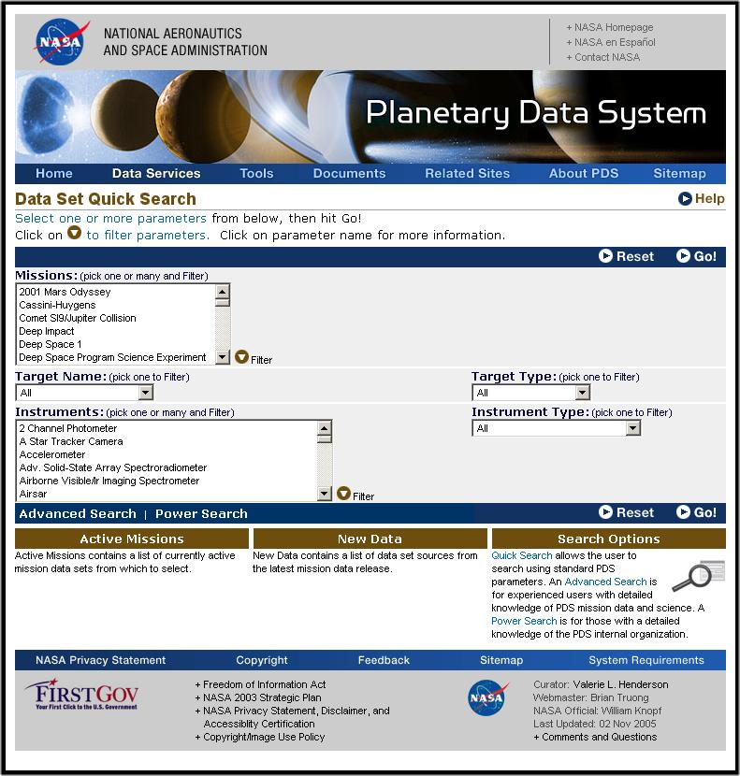

- PDS Explorer

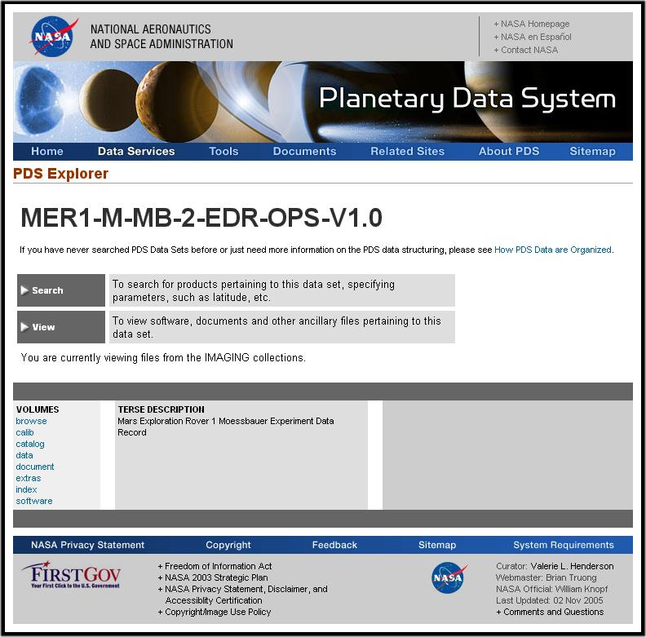

- PDS Subscription Page

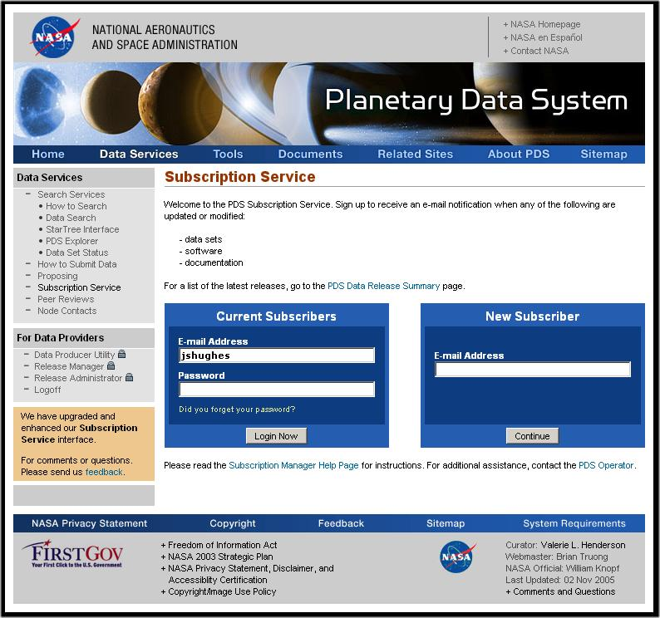

- PDS Reference Lookup

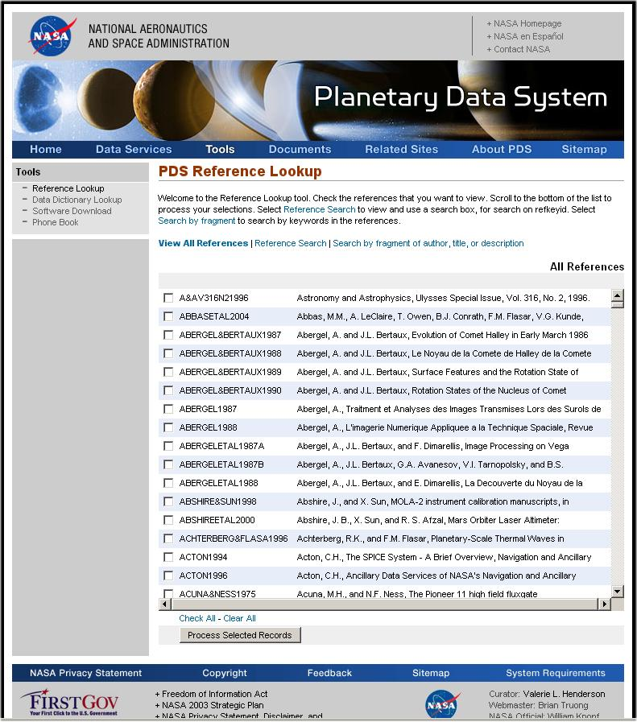

- PDS Data Dictionary Lookup

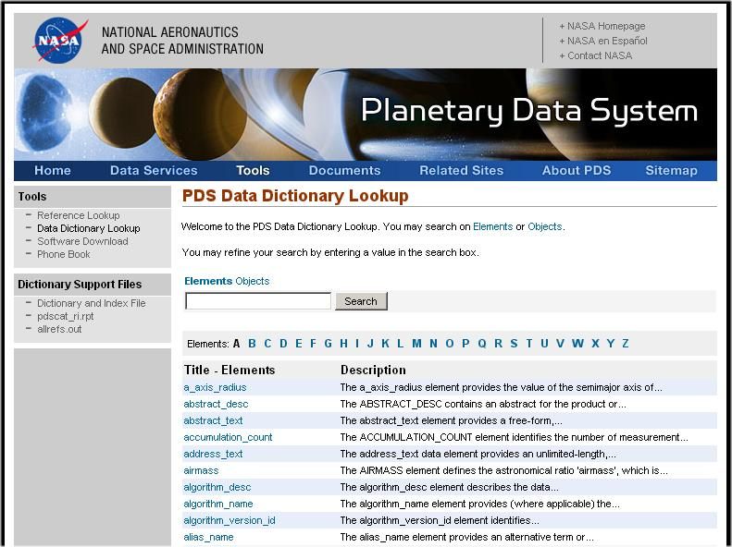

- PDS Software Download Page

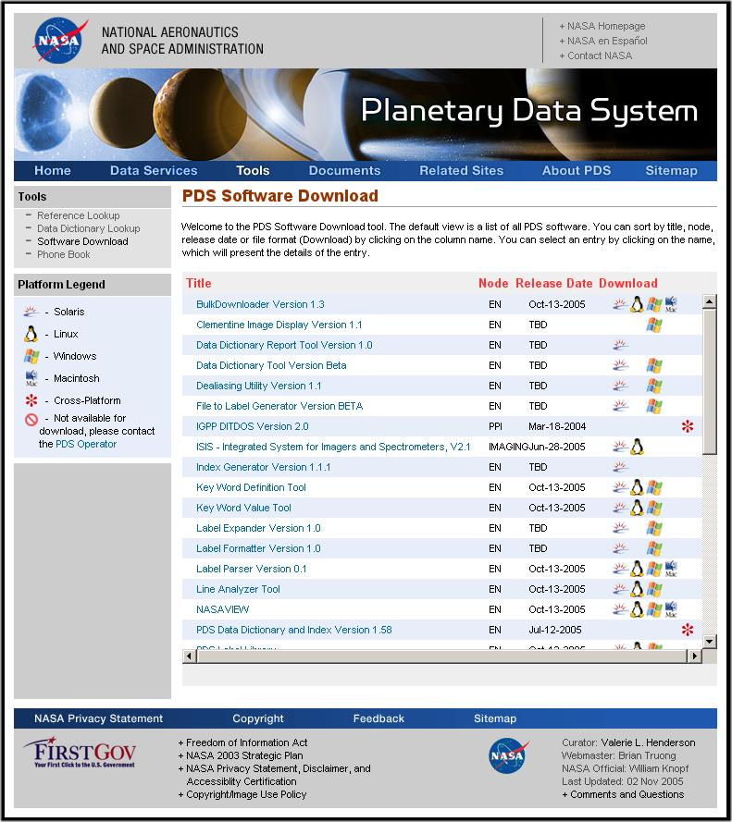

- PDS Phone Book

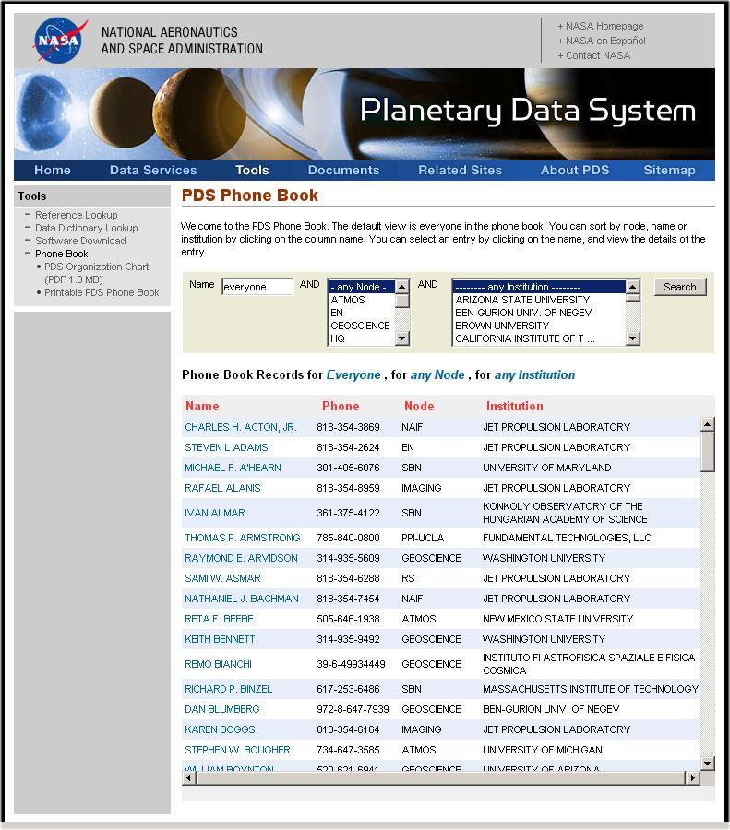

- PDS Engineering Home Page

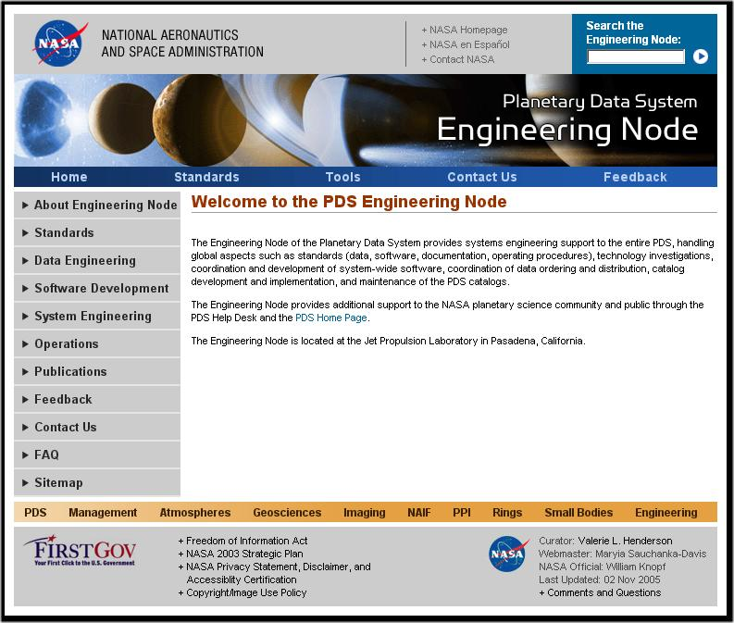

                - Acronyms

The table below lists acronyms and abbreviations used in this document.

ACRONYM | DEFINITION
DE | Data Engineer
EN | Engineering Node
HTTP | A protocol used to request and transmit files over the Internet or other computer network
ODL | Object Definition Language
PDS | Planetary Data System
PSDD | Planetary Science Data Dictionary
JPL | Jet Propulsion Laboratory

Table A-1. Acronyms and abbreviations

