PDS Mirror Site

Installation Guide

May 01, 2006
Version 0.060501





Jet Propulsion Laboratory
Pasadena, California

CHANGE LOG

Revision | Date | Description | Author
0.060401 | April 01, 2006 | Initial draft. | A. Leung
0.060501 | May 01, 2006 | Formatted as an RDD including information on installation. | A. Leung  R. Joyner
Table of Contents

1.0 INTRODUCTION 4
1.1 Purpose 4
1.2 Scope 4
1.3 Audience 4
1.4 Applicable Documents 4
2.0 Installation PROCEDURES 5
2.1 Planet Data System Webpage Server (PDS/WPS) 5
2.1.1 Red Hat Enterprise Linux ES release 4.0 (Nahant) 5
2.1.2 Perl5 (revision 5 version 8 subversion 5) 6
2.1.3 Java(TM) 2 Runtime Environment, Standard Edition (build 1.4.2_09-b05) 6
2.1.4 Apache Version 2.0.4 6
2.1.5 Macromedia Coldfusion MX Version 6.1.0 9
2.1.6 PostgreSQL Database Management System Version 8.0.3 11
2.1.7 Vsftpd Version 2.0.1 13
2.2 Planet Data System Webapps Server (PDS/WAS) 13
2.2.1 Red Hat Enterprise Linux ES release 4.0 (Nahant) 14
2.2.2 Perl5 (revision 5 version 8 subversion 5) 14
2.2.3 Java(TM) 2 Runtime Environment, Standard Edition (build 1.4.2_09-b05) 14
2.2.4 Mysql (revision 4 version 0 subversion 21) 14
2.2.5 Apache Tomcat Server (revision 5 version 5 subversion 9) 15
2.2.6 PDS-D Central Server (revision 2 version 1 subversion 0) 16
2.2.7 PDS-D Profile Server (revision 1 version 0 subversion 3) 16
2.2.8 Migrate the PDS web applications to Apache Tomcat Server 16
2.3 Planet Data System Catalogue Server (PDS/CS) 18
3.0 BACKUP 20
3.1 Planet Data System Mirror Site backup 20
4.0 Monitoring 26
4.1 Planet Data System Mirror Site Monitoring 26
4.2 Planet Data System Mirror Site Firewall 28
APPENDIX A 29

INTRODUCTION

The Planetary Data System (PDS) Mirror Site (PDS/MS) ensures that the PDS online capabilities remain operational at an acceptable level in the event that Engineering Node (EN) infrastructure fails catastrophically.

Purpose

The purpose of this document is to provide a detailed description of the procedures required to install the PDS Mirror Site. This document also describes how to verify and test the functionality of the systems that comprise the PDS/MS:

- Planet Data System Webpage Server (PDS/WPS)
- Planet Data System Webapps Server (PDS/WAS)
- Planet Data System Catalogue Server (PDS/CS)

Scope

This document covers the procedures that were used in March/06 to install the components comprising the PDS/MS.

Audience

This document is written primarily for those who might have a need to re-install or test the installation of the PDS/MS.

Applicable Documents

[1] None

Installation PROCEDURES

The procedures for installing the components comprising the PDS/MS are detailed in this section:

- Planet Data System Webpage Server (PDS/WPS)
- Planet Data System Webapps Server (PDS/WAS)
- Planet Data System Catalogue Server (PDS/CS)

There is no installation dependency between the first two subsystems (i.e., either the PDS/WPS or the PDS/WAS can be installed in any order). However, the PDS/CS can only be installed after both the PDS/WPS and PDS/WAS subsystems have been successfully installed.

Planet Data System Webpage Server (PDS/WPS)

This section describes the software dependencies amongst the PDS/WPS components; as well as, the procedure for installing those components.

The following table lists the software dependencies amongst the PDS/WPS components:

Software | Version
Red Hat Enterprise Linux ES | release 4.0
Perl 5 | 5.8.5
J2SE Development Kit (JDK) | 1.4.2_09
Apache Server | 2.0.49
Coldfusion MX | 6.1.0
PostgreSQL | 8.0.3
Vsftpd | 2.0.1

The remainder of this section is devoted to describing the installation steps for each of the components listed in the above table.

Red Hat Enterprise Linux ES release 4.0 (Nahant)
  - Install from the Red Hat Enterprise Linux ES release 4.0 CD.
  - Check and verify what version of Red Hat Linux operating system is in used with the following command:

cat /etc/redhat-release

Perl5 (revision 5 version 8 subversion 5)
- Ensure DBI and DBD::mysql are installed by the following command:
  - To verify DBI software module with the following command:

perldoc DBI

  - To verify DBD::mysql software module with the following command:

perldoc DBD::mysql
- If not, install it with the following standard command::

Perl –CPAN –e shell

Java(TM) 2 Runtime Environment, Standard Edition (build 1.4.2_09-b05)
- Download the Java Runtime packages from the Sun Developer Network web site (http://java.sun.com)
- Un-tar, configure and make the downloaded binaries and create the /apps/ j2sdk1.4.2_09 software.
- Ensure the symbolic link /usr/java/jdk is pointing to the new installation.
- Check and verify that the appropriate version of the J2SE Development Kit (JDK) is used with the following command

/usr/java/jdk/bin/java –version

Apache Version 2.0.4
- Download the apache httpd packages from the Apache Software Foundation web site (http://www.apache.org)
- Un-tar, configure and make the downloaded binaries and create the /usr/local/apache3 software.
- Transfer data under /data/www/pds from starbeam to mirpds.X.
- Modify /usr/local/apache3/conf/httpd.conf by replacing the following changes:

Old settings | New settings
User nobody | User apache
Group -1 | Group apache
admin@your-domain.com | ServerAdmin root@localhost
#ServerName www.example.com:80 | ServerName mirpds.jpl.nasa.gov:80
#DocumentRoot "/usr/local/apache3/htdocs" | DocumentRoot "/data/www/pds/htdocs"
<Directoryusr/local/apache3/htdocs">  Options Indexes FollowSymLinks  AllowOverride None  Order allow,deny  Allow from all  </Directory> | <Directory "/data/www/pds/htdocs">  Options Indexes FollowSymLinks  AllowOverride None  Order allow,deny  Allow from all  </Directory>
Alias /icons/ "/usr/local/apache3/icons/"  <Directory "/usr/local/apache3/icons/">  Options Indexes MultiViews  AllowOverride None  Order allow,deny  Allow from all  </Directory> | Alias /icons/ "/data/www/pds/icons/"  <Directory "/data/www/pds/icons">  Options Indexes MultiViews  AllowOverride None  Order allow,deny  Allow from all  </Directory>
ScriptAlias /cgi-bin/ "/usr/local/apache3/cgi-bin/"  <Directory "/usr/local/apache3/cgi-bin">  Options ExecCGI FollowSymLinks  Order allow,deny  Allow from all  </Directory> | ScriptAlias /cgi-bin/ "/data/www/pds/cgi-bin/"  <Directory "/data/www/pds/cgi-bin">  Options ExecCGI FollowSymLinks  Order allow,deny  Allow from all  </Directory>

- Modify the /usr/local/apache3/conf/httpd.conf configuration file to add the followings

NameVirtualHost *:80

<VirtualHost *:80>
ServerName mirpds.X
ServerAdmin alex.leung@jpl.nasa.gov
DocumentRoot /data/www/pds/htdocs
ErrorLog /usr/local/apache3/logs/error_log
TransferLog /usr/local/apache3/logs/access_log
</VirtualHost>

<VirtualHost *:80>
ServerName mirpds
ServerAdmin alex.leung@jpl.nasa.gov
DocumentRoot /data/www/pds/htdocs
ErrorLog /usr/local/apache3/logs/error_log
TransferLog /usr/local/apache3/logs/access_log
</VirtualHost>

<VirtualHost *:80>
ServerName pds.jpl.nasa.gov
ServerAdmin alex.leung@jpl.nasa.gov
DocumentRoot /data/www/pds/htdocs
ErrorLog /usr/local/apache3/logs/error_log
TransferLog /usr/local/apache3/logs/access_log
</VirtualHost>

<VirtualHost *:80>
ServerName pds
ServerAdmin alex.leung@jpl.nasa.gov
DocumentRoot /data/www/pds/htdocs
ErrorLog /usr/local/apache3/logs/error_log
TransferLog /usr/local/apache3/logs/access_log
</VirtualHost>

- Add the followings to Apache configuration file (/usr/local/apache3/conf/httpd.conf ) for “Welcome to the Planets home page”

#Welcome to the Planets home page
Alias /planets "/data/www/wtp/planets"
Alias /wtp "/data/www/wtp/planets"

<Directory "/data/www/wtp/planets">
Options FollowSymLinks
AllowOverride None
Order allow,deny
Allow from all
</Directory >

- Add the followings to /usr/local/apache3/conf/httpd.conf for “Data Preparation Workbook Documentations”:

# Data Preparation Workbook Documentations:
Alias /dpw "/data/www/dpw"

<Directory "/data/www/dpw">
Options FollowSymLinks
AllowOverride None
Order allow,deny
Allow from all
</Directory >

- Add the followings to /usr/local/apache3/conf/httpd.conf for “Standard Reference Documentations”:

# Standard Reference Documentations:
Alias /stdref "/data/www/stdref"

<Directory "/data/www/stdref">
Options FollowSymLinks
AllowOverride None
Order allow,deny
Allow from all
</Directory>

- Add the followings to /usr/local/apache3/conf/httpd.conf for “PDS quick start information”:

# PDS quick start Information:
Alias /qs "/data/www/qs"
Alias /qs/ "/data/www/qs/"

<Directory "/data/www/qs">
Options None
AllowOverride AuthConfig Limit
Order allow,deny
Allow from all
</Directory>

- Add the followings to /usr/local/apache3/conf/httpd.conf for “PDS Documentation Information”

# PDS Documentation Information
Alias /pag "/data/www/pag"
Alias /pag/ "/data/www/pag/"

<Directory "/data/www/pag">
Options None
AllowOverride AuthConfig Limit
Order allow,deny
Allow from all
</Directory>

- Start up the Apache server with the following command:

/usr/local/apache3/bin/apachectrl start

- Verify that the PDS web page is displayed at.

http://mirpds.X

Macromedia Coldfusion MX Version 6.1.0
- Install Macromedia Coldfusion MX Version 6.1.0 CD Media.
- Ensure the /usr/local/apache3/conf/httpd.conf configuration file has the following changes:
DirectoryIndex index.html index.html.var index.cfm

Alias /CFIDE "/usr/local/apache3/htdocs/CFIDE"
Alias /cfide "/usr/local/apache3/htdocs/CFIDE"

<Directory "/usr/local/apache3/htdocs/CFIDE">
Options Indexes FollowSymLinks MultiViews IncludesNoExec
AddOutputFilter Includes html
AllowOverride None
Order allow,deny
Allow from all
</Directory>

# JRun Settings
LoadModule jrun_module /apps/coldfusionmx/runtime/lib/wsconfig/1/mod_jrun20.so
LoadModule php5_module modules/libphp5.so
<IfModule mod_jrun20.c>
JRunConfig Verbose false
JRunConfig Apialloc false
JRunConfig Ssl false
JRunConfig Ignoresuffixmap false
JRunConfig Serverstore /apps/coldfusionmx/runtime/lib/wsconfig/1/jrunserver.store
JRunConfig Bootstrap 127.0.0.1:51010
#JRunConfig Errorurl <optionally redirect to this URL on errors>
AddHandler jrun-handler .jsp .jws .cfm .cfml .cfc
</IfModule>

- Start the Coldfusion MX packages with the following command

/etc/init.d/coldfusionmx start

- Restart the Apache server with the following command:

/usr/local/apache3/bin/apachectrl restart

- Configure Data Source with the following command:

  - Login to the administrative web (http://mirpds.X/cfide/administrator)
  - Choose “Data Sources” from the left side Table under “DATA SERVICES”
  - Input dbonline into the box on “Data Source Name” under “Add New Data Source”, and click “Add” to execute the command
  - Input jdbc:sybase:Tds:starsyb:4100/dbonline under “JDBC URL”
  - Input com.sybase.jdbc2.jdbc.SybDriver under “Driver Class”.
  - Input Sybase under “Driver Name”.
  - Input sa for “Username”
  - Key in password for sa in your Sybase database server under “Password”

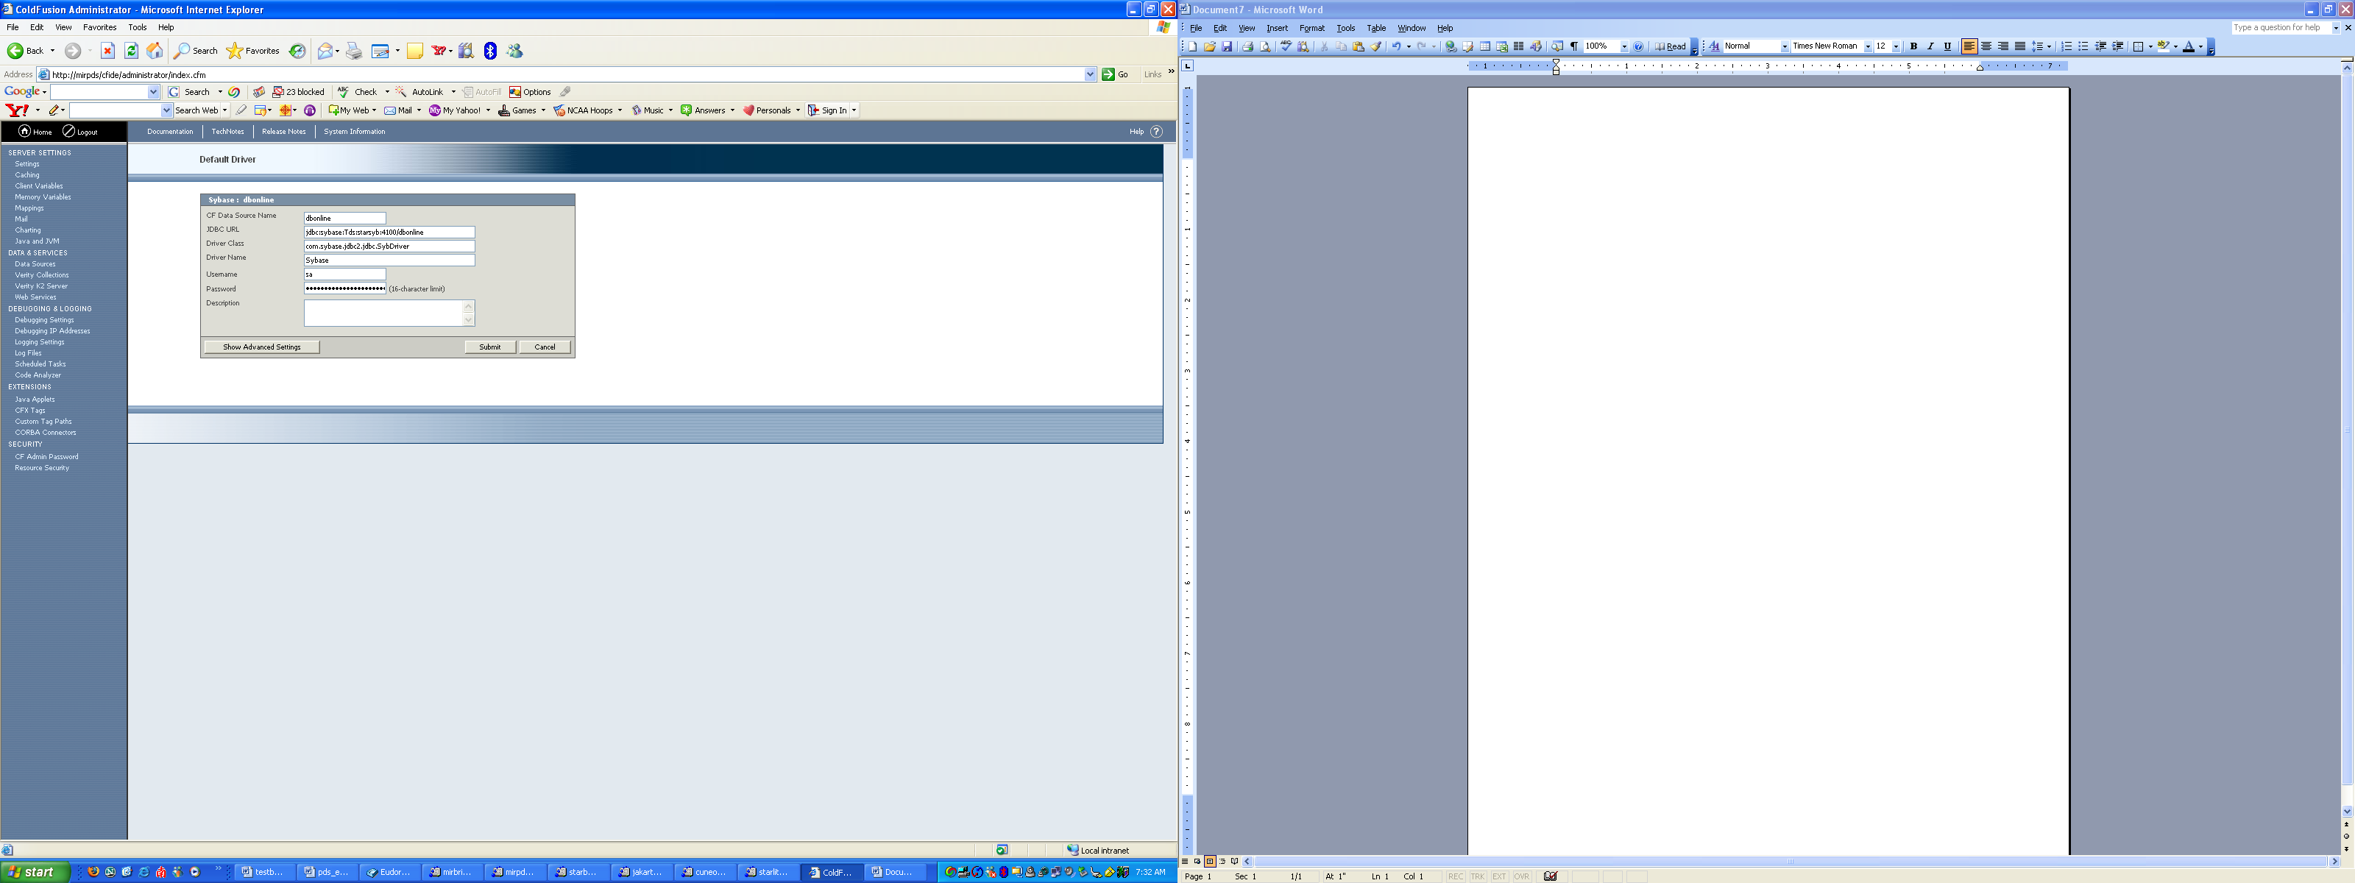

- Verify that the PDS Engineering page is displayed at

http://mirpds.X/tools/data_dictionary_lookup.cfm

PostgreSQL Database Management System Version 8.0.3
- Download the PostgreSQL packages from the PostgreSQL Global Development Group web site (http://www.postgresql.org)
- Un-tar, configure and make the downloaded binaries and create the /usr/local/pgsql software:
- Transfer PDS Engineering Node data from starbeam.jpl.nasa.gov with the following command
  - From starbeam, tar up /usr/local/pgsql/data and copy across to server mirpds.X
  - From starbeam, stop postgresql by using

/etc/init.d/postgresql stop

  - From mirpds.X, untar tarball to /usr/local/pgsql
  - From mirpds.X, start postgresql by using

/etc/init.d/postgresql start

- Ensure /usr/local/pgsql/data/pg_hba.conf has the following updates:

# mirpds
host dbpds_engineering all 137.78.33.49/32 trust

- Shutdown the Apache server with the following command:

/usr/local/apache3/bin/apachectrl stop

- Modify the /usr/local/apache3/conf/httpd.conf configuration file to add the followings:

ScriptAlias /search-bin/ "/data/www/pds/htdocs/engineering/search-bin/"

<Directory "/data/www/pds/htdocs/engineering/search-bin">
Options ExecCGI FollowSymLinks
Order allow,deny
Allow from all
</Directory>

</VirtualHost *:80>
ServerName pds-engineering.X
ServerAdmin alex.leung@jpl.nasa.gov
DocumentRoot /data/www/pds/htdocs/engineering
ErrorLog /usr/local/apache3/logs/pds-engineering-error_log
TransferLog /usr/local/apache3/logs/pds-engineering-access_log
</VirtualHost>

<VirtualHost *:80>
ServerName pds-engineering
ServerAdmin alex.leung@jpl.nasa.gov
DocumentRoot /data/www/pds/htdocs/engineering
ErrorLog /usr/local/apache3/logs/pds-engineering-error_log
TransferLog /usr/local/apache3/logs/pds-engineering-access_log
</VirtualHost>

- Shutdown the Apache server with the following command:

/usr/local/apache3/bin/apachectrl start

- Verify that the PDS Engineering page is displayed at:

http://mirpds.X/engineering

Vsftpd Version 2.0.1
- Download the Vsftpd packages from the Official Secure and Fastest FTP web site (http://vsftpd.beasts.org).
- Un-tar, configure and make the downloaded binaries and create the /var/ftp directory
- Transfer data under /var/ftp/pub from starbeam to mirpds.X.
- Verify by login to the ftp server with the following command:

[root@mirpds pub]$ ftp mirpds.X
Connected to mirpds.
220 (vsFTPd 2.0.1)
530 Please login with USER and PASS.
530 Please login with USER and PASS.
KERBEROS_V4 rejected as an authentication type
Name (mirpds:root): anonymous
331 Please specify the password.
Password:
230 Login successful.
Remote system type is UNIX.
Using binary mode to transfer files.

Planet Data System Webapps Server (PDS/WAS)

This section describes the software dependencies amongst the PDS/WAS components; as well as, the procedure for installing those components.

The following table lists the software dependencies amongst the PDS/WAS components:

Software | Version
Red Hat Enterprise Linux ES | release 4.0
Perl 5 | 5.8.5
J2SE Development Kit (JDK) | 1.4.2_09
Apache Tomcat Server | 5.5.9
MySQL | 4.0.21
PDS-D Central Server | 2.1.0
PDS-D Profile Sercer | 1.0.3

The remainder of this section is devoted to describing the installation steps for each of the components listed in the above table.

Red Hat Enterprise Linux ES release 4.0 (Nahant)
- Install from the Red Hat Enterprise Linux ES release 4.0 CD.
- Check and verify what version of Red Hat Linux operating system is in used with the following command:

cat /etc/redhat-release

Perl5 (revision 5 version 8 subversion 5)
- Ensure DBI and DBD::mysql are installed by the following command:
  - To verify DBI software module with the following command:

perldoc DBI

  - To verify DBD::mysql software module with the following command:

perldoc DBD::mysql
- If not, install it with the following standard command::

Perl –CPAN –e shell

Java(TM) 2 Runtime Environment, Standard Edition (build 1.4.2_09-b05)
- Download the Java Runtime packages from the Sun Developer Network web site (http://java.sun.com)
- Un-tar, configure and make the downloaded binaries and create the /apps/ j2sdk1.4.2_09 software.
- Ensure the symbolic link /usr/java/jdk is pointing to the new installation.
- Check and verify that the appropriate version of the J2SE Development Kit (JDK) is used with the following command

/usr/java/jdk/bin/java –version

Mysql (revision 4 version 0 subversion 21)
- Download the MySQL packages from the official MySQL web site (http://www.mysql.org)
- Un-tar, configure and make the downloaded binaries and create the /usr/local/mysql software
- Transfer MySQL data from starbrite.jpl.nasa.gov with the following command

  - From starbrite, tar up /usr/local/mysql/data and copy across to server mirbrite.X
  - From starbrite, stop MySQL by using /etc/init.d/mysqld stop
  - From mirpds.X, untar tarball to /usr/local/mysql
  - From mirpds.X, start MySQL by using /etc/init.d/mysqld start

- Verify MySQL database had the lastest updates with the following command:

# mysql –u root –p
mysql> show database;

Apache Tomcat Server (revision 5 version 5 subversion 9)
- Download the Apache Tomcat packages from the Apache Software Foundation web site (http://tomcat.apache.org).

  - tomcat 5.5.9
  - tomcat 5.5.9-compat
  - tomcat 5.5.9-admin

- Un-tar, configure and make the downloaded binaries and create the /usr/local/tomcat5 software.
- Modify the /usr/local/tomcat5/conf/server.xml configuration file to change the non-SSL Connector port number from 8080 to 80.
- Modify the /usr/local/tomcat5/conf/web.xml file by un-commenting the blocks containing the invokers (e.g. <sevlet> and <servlet-mapping>).
- Start up the Tomcat server with the following command:

[root@pdsdlbX] /usr/local/tomcat5/bin/startup.sh

- Verify that the local Tomcat main page is displayed at:

http://mirbriteX/
.
- Shutdown the Tomcat server with the following command:

[root@pdsdlbX] /usr/local/tomcat5/bin/shutdown.sh

PDS-D Central Server (revision 2 version 1 subversion 0)
- Download the PDS-D Central Server packages from the Object Oriented Data Technology web site ((http://oodt.jpl.nasa.gov/pds-cn/)
- Un-tar, configure and make the downloaded binaries and create the /usr/local/pds software

PDS-D Profile Server (revision 1 version 0 subversion 3)
- Download the PDS-D Profile Server packages from the Object Oriented Data Technology web site (http://oodt.jpl.nasa.gov/pds-profile/)
- Un-tar, configure and make the downloaded binaries and create the /usr/local/pds-profile software

Migrate the PDS web applications to Apache Tomcat Server
- Copy web application files and/or directories and their dependencies from the old Tomcat directory over to the new Tomcat environment using the following mapping (all locations are under the Tomcat installation directory)

Old Location | New Location
webapps/db | webapps/db
webapps/dsstatus | webapps/dsstatus
webapps/pds-explorer | webapps/pds-explorer
common/lib/jconn2.jar | common/lib/jconn2.jar
conf/Catalina/localhost/dsviewdb.xml | webapps/ROOT/META-INF/context.xml  ** META-INF is a new directory. context.xml file has a different layout to dsviewdb.xml. See appendix A
webapps/ROOT/dtd/ | webapps/ROOT/dtd/
webapps/ROOT/pds/ | webapps/ROOT/pds/
webapps/ROOT/xsl/ | webapps/ROOT/xsl/
webapps/ROOT/WEB-INF/ | webapps/ROOT/WEB-INF/
webapps/ROOT/tst.html | webapps/ROOT/tst.html
webapps/ROOT/catalog_tools | webapps/ROOT/catalog_tools  ** this assumes that the Resource Manager has already been installed

- Synchronize jar file and class file dependencies with the ones used by the Profile Servers. This is very important, if not completed, the portions of the software communicating with the Profile Servers will not work. The following table describes the location of jar files or class files that each depend on and their locations. The version numbers are based on the current version as of the time this document was written..

Application name | jar/class file location related to Tomcat installation root | jar/class file names
Basic Browser | webapps/db/WEB-INF/lib | edm-commons-2.2.9.jar  edm-query-2.0.5.jar  grid-product-3.0.7.jar  grid-profile-3.0.5.jar  grid-query-3.0.3.jar  jconn2-5.5.jar  jena-1.6.1.jar  junit.jar  mysql-connector-java-3.0.15-ga-bin.jar  pds-utils-1.0.1.jar
DS Status | webapps/db/dsstatus/WEB-INF/lib | jconn2-5.5.jar  pds-utils-1.0.1.jar
DS View | webapps/ROOT/WEB-INF/lib | catalina-root.jar  edm-commons-2.2.9.jar  edm-query-2.0.5.jar  grid-product-3.0.7.jar  grid-profile-3.0.5.jar  grid-query-3.0.3.jar  jconn2-5.5.jar  jena-1.6.1.jar  junit.jar  mysql-connector-java-3.0.15-ga-bin.jar  oracle.jar  pds.jar  pds-utils-1.0.1.jar  ** pds.jar is a PDS EN generated jar file
PDS Explorer | webapps/pds-explorer/WEB-INF/lib | edm-commons-2.2.9.jar  edm-query-2.0.5.jar  grid-product-3.0.7.jar  grid-profile-3.0.5.jar  jconn2-5.5.jar  pds-utils-1.0.1.jar
Resource Manager | webapps/ROOT/WEB-INF/classes/catalog_tools | ADMSession.class  ** this class file is generated by running compile.sh script inside the catalog_tools application directory

- Restart up the Server Manager, Tomcat Server, Name Server, and all Profile Servers with the following command

[root@pdsdlbX] /etc/init.d/pds restart

Planet Data System Catalogue Server (PDS/CS)

Note that the PDS/CS can only be installed after both the PDS/WPS and PDS/WAS subsystems have been successfully installed.

This section describes the software dependencies amongst the PDS/CS components; as well as, the procedure for installing those components.

Software | Version
Sybase Adaptive Server Enterprise | release 12.5.2

The following steps are required to install the components that comprise the PDS/CS:

- Install Sybase Adaptive Server Enterprise (revision 12 version 5 subversion 2)

  - Download the Adaptive Server Enterprise from Sybase official web site (http://www.sybase.com).

  - Un-tar and configure the downloaded binaries to /apps/sybase directory.

  - Setup the Sybase Adaptive Server Enterprise to /Sybase directory with the following command:

setup

  - Configure and create raw device database storage with the following command:
    - Modify the /etc/init.d/Sybase startup script to increase the shared memory for Sybase to run with the followings:

echo 268435456 > /proc/sys/kernel/shmmax

    - Add the following entries to the /etc/sysconfig/rawdevices configuration file:

/dev/raw/raw1 /dev/sdc1
/dev/raw/raw2 /dev/sdc2
/dev/raw/raw5 /dev/sdc5
/dev/raw/raw6 /dev/sdc6

    - Activate the raw devices with the following command manually or insert it in the boot up sequence:

chmod 666 /dev/raw/raw5
chmod 666 /dev/raw/raw6

For manual start
service rawdevices start

For automatic start
chkconfig rawdevices on

To verify the settings
raw -qa

    - Initialize log_dev and peer_dev with the following steps:

>disk init name="tempdb_def", size="2048M", physname="/sybase/data/tempdb_def.dat", dsync=false
>go
>disk init name="tempdb_log", size="1024M", physname="/sybase/data/tempdb_log.dat", dsync=false
> go
>disk init name="tempdb_sys", size="1024M", physname="/sybase/data/tempdb_sys.dat", dsync=false
> go

    - Transfer sys user logins with the following steps.

bcp master..syslogins out syslogin_starsyb.bcp -c -Usa -Pnew4sa -SSYBASECN2
then scp syslogin_starsyb.bcp mirbrite:/sybase
on mirbrite
first remove suid 1 and 2 entries from syslogins_starsyb.bcp
second login to isql do sp_configure "allow updates to system tables",1
third bcp master..syslogins in syslogins_starsyb.bcp -c -Usa -Pxxxxxxx -SPDSYBASECN2
third login to isql do sp_configure "allow updates to system tables",0

    - Migrate database across from starsyb to Mirror Site with the following procedures.

1>create database dbonline on peer_dev=100
2> log on log_dev=50 for load
3> go

1> load database dbonline from "/sybase/dbonline_dump"
2> go

1> online database dbonline
2> go

1> create database dbonlinedev on peer_dev=100
2> log on log_dev=50 for load
3> go

1> load database dbonlinedev from "/sybase/dbonlinedev_dump"
2> go

1> online database dbonlinedev
2> go

1>create database distribution on peer_dev=200
2> log on log_dev=100 for load
3> go

1>load database distribution from "/sybase/distribution_dump"
2> go

1> online database distribution
2> go

BACKUP

This section details the procedure for installing the raid 1 mirror technology and data synchronization applications setup..

Planet Data System Mirror Site backup

The following are the steps to install the Planet Data System Mirror Site backup.

- Ensure the following hardware, firmware and drivers versions:

  - AMCC 3ware 9500S-4LP SATA Raid Controller
  - Firmware version FE9X 2.08.00.006
  - Driver version 2.26.04.007

- Configure system with dual hard raid 1 as follow:

  - Download the 3ware 3DM2 Management Utility from 3ware official web site (http://www.3ware.com).
  - Un-tar and configure the downloaded binaries to /apps/3dm2 directory.
  - Setup the 3DM2 Management Graphic Utility with the following command:

install.3dm -i

  - Connect to the SATA Raid Controller with the following URL:

https://localhost:888

login to the web site as Administrator with default password as “3ware”.

  - Configure boot up system with dual hard disks:

    - After login to the Management Utility, choose “Maintenance” tab under “Management” icon from the title bar.
    - Check marks Unit 0 under “Unit maintenance (Controller ID 0)” section.
    - Click Migrate Unit under the same section.
    - Choose Port X under the “Select drive to use to migrate” section from the pop-up window.
    - Choose “Raid 1 Type” and click “OK” to perform task from the pop-up window.
    - Rebuilding percentage will be display on the same screen under the unit that had been chosen.

  - The Graphic Utility Interfaces screenshot display will look like the following:

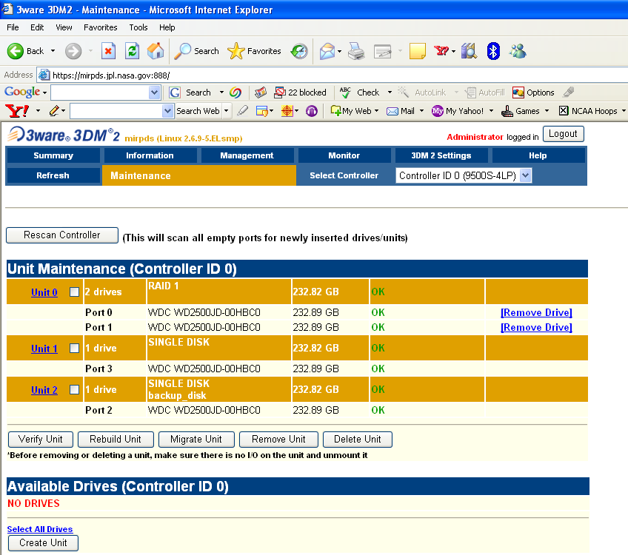

  - Configure duplicate boot disk

    - Reasons for the boot disk duplication:

      - As a proactive task in case of primary boot disk failure.
      - As a baseline before performing operating system upgrade and/or software patches upgrade.
      - As an weekly backup pool for the local mirror site backup.

    - Steps to configure duplicate boot disk

      - login to the Management Utility, choose “Maintenance” tab under “Management” icon from the title bar.
      - Check marks Unit 0 (raid 1) under “Unit maintenance (Controller ID 0)” section.
      - Click Migrate Unit under the same section.
      - Choose “Single Disk Type” and click “OK” to perform task from the pop-up window.
      - Two separated single disk from the raid 1 unit will be formed.
      - Check marks either one of the single disk from the raid 1 unit under “Unit maintenance (controller ID 0)”section.
      - Click “Migrate Unit” under the same section.
      - Choose Port X under the “Select drive to use to migrate” section from the pop-up window.
      - Choose “Raid 1 Type” and click “OK” to perform task from the pop-up window.
      - Rebuilding percentage will be display on the same screen under the unit that had been chosen.
      - A dual disk raid 1 unit and a duplicate single disk will be configure and setup for secondary boot up.
      - Verify backup single disk and raid 1 disks are available with the following command:

fdisk –l

      - Label the duplicate volume different from the original with the following commands:

E2label /dev/sd

- Configure local system online backup:

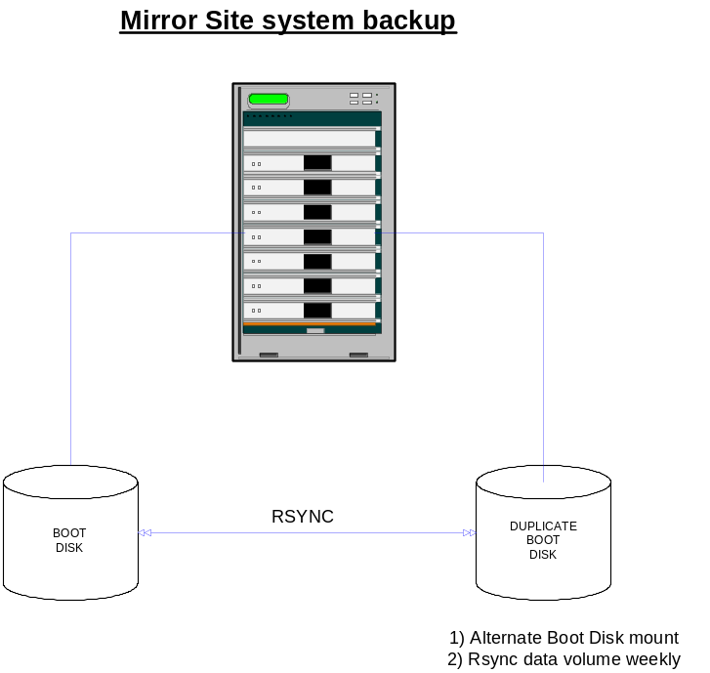

  - Configure rsync and crontab scripts for local data backup

    - Under crontab on server mirpds, a script was created to synchronize data from the primary disk to the mirror disk.

Under crontab on server mirpds, a script was created to sync /, /boot, /home and /usr/local from primary disk to mirror disk.
0 23 * * 6 /apps/cronbin/disksync

    - Under crontab on server mirbrite, a script was created to synchronize data from the primary disk to the mirror disk

Under crontab on server mirbrite, a script was created to sync /, /boot, /home and /usr/local from primary disk to mirror disk.

0 23 * * 6 /apps/cronbin/disksync

- Configure remote system online backup:

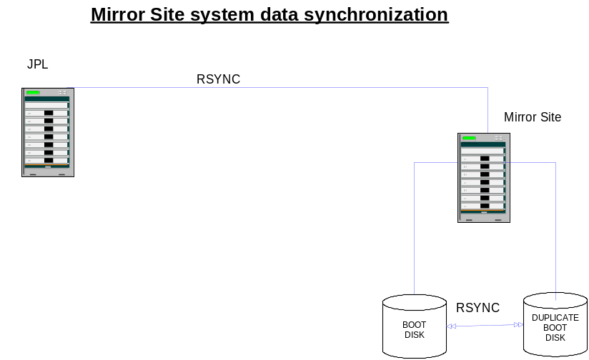

  - Configure rsyncd and crontab scripts for remote data backup

    - Under crontab on server pdsweb2, a script was created to synchronize data from the primary site to the mirror site
datarsync -- script for data synchronization of webpage directories.

0 23 * * 6 /apps/cronbin/datarsync

  - Configure database rsync scripts for mirror site Sybase data synchronization with site

- Under crontab on server stardb, a script was created to scp dbonline_dump from the starsyb site to the mirror site.

scpdbonline -- script to copy dbonline_dump from starsyb to mirbrite.

0 23 * * 5 /apps/cronbin/scpdbonline

- Under Sybase crontab on server mirbrite, a refresh script was created to update and activate changes.

uploadonline -- script for update changes and activate mirror Sybase server.

0 23 * * 6 /Sybase/sbin/uploadonline

  - Configure database rsync scripts for mirror site Postgresql data synchronization with primary site.

- Under crontab on server pdsweb2, a script was created to synchronize data from the primary site to the mirror site.

pgsqlrsync -- script for data synchronization of the PostgreSQL database server.

0 23 * * 5 /apps/cronbin/pgsqlrsync

- Under crontab on server mirpds, a postgresql refresh script was created to update and activate changes.

pgsqlrsync -- script for data synchronization of the PostgreSQL database server.

0 23 * * 6 /apps/cronbin/pgsqlrsync

  - Configure database rsync scripts for mirror site Mysql data synchronization with primary site.

    - Under crontab on server pdsdlb2, a script was created to synchronize data from the primary site to the mirror site.

mysqlsync -- script for data synchronization of MySQL database server.

0 23 * * 5 /apps/cronbin/mysqlsync

    - Under crontab on server mirbrite, a refresh script was created to update and activate changes.

mysqlsync -- script for update changes and activate MySQL database server.

0 23 * * 6 /apps/cronbin/mysqlsync

  - Configure rsync scripts for mirror site webapps data synchronization with primary site.

- Under crontab on server pdsdlb2, a script was created to synchronize data from the primary site to the mirror site

tomcat5sync -- script for update changes and activate webapps server.

0 23 * * 5 /apps/cronbin/tomcat5sync

- Under crontab on server mirbrite, a refresh script was created to update and activate changes.

tomcat5sync -- script for update changes and activate webapps server.

0 23 * * 6 /apps/cronbin/tomcat5sync

- Configuration file synchronization had to be performed manually by CM or SA from JPL.

Monitoring

This section details the procedure for installing the Nagios monitoring software:

Planet Data System Mirror Site Monitoring

The following are the steps to install the Nagios nrpe client software packages.

- Install Nagios nrpe software packages
  - Download the Nagios nrpe packages from the official web site (http://www.nagios.com)
  - Un-tar and configure the downloaded binaries to /usr/local/nagios directory
  - Modify the /etc/nrpe.cfg file by adding the following blocks:

server_port=5666

allowed_hosts=127.0.0.0,10.0.1.15,137.78.33.27

command[check_users]=/usr/local/nagios/plugins/check_users -w 8 -c 10
command[check_load]=/usr/local/nagios/plugins/check_load -w 15,10,5 -c 30,25,20
command[check_disk1]=/usr/local/nagios/plugins/check_disk -w 20 -c 10 -p /dev/sda1
command[check_disk2]=/usr/local/nagios/plugins/check_disk -w 20 -c 10 -p /dev/sda7
command[check_zombie_procs]=/usr/local/nagios/plugins/check_procs -w 5 -c 10 -s Z
command[check_total_procs]=/usr/local/nagios/plugins/check_procs -w 250 -c 300

  - Modify the permission of the /etc/nrpe.cfg file with the following command

chmod 644 /etc/nrpe.cfg

  - Modify the /etc/services file by adding the following blocks

chmod 644 /etc/nrpe.cfg

  - Create /etc/xinetd.d/nrpe file for nrpe client to run automatically
service nrpe
{
flags = REUSE
socket_type = stream
wait = no
user = nagios
server = /usr/sbin/nrpe
server_args = -c /etc/nrpe.cfg --inetd
log_on_failure += USERID
disable = no
only_from = 127.0.0.0 137.78.33.140 10.0.1.15 137.78.33.27
}
  - Restart the xinet daemon by the following command

/etc/init.d/xinetd restart

  - Verify the software client setup locally by using the following command:

/usr/local/nagios/plugin/bin/check_nrpe -H localhost

  - After modification of the setup for the client from the nagios server (starfame), the Graphic Utility Interfaces screenshot display will look like the following:

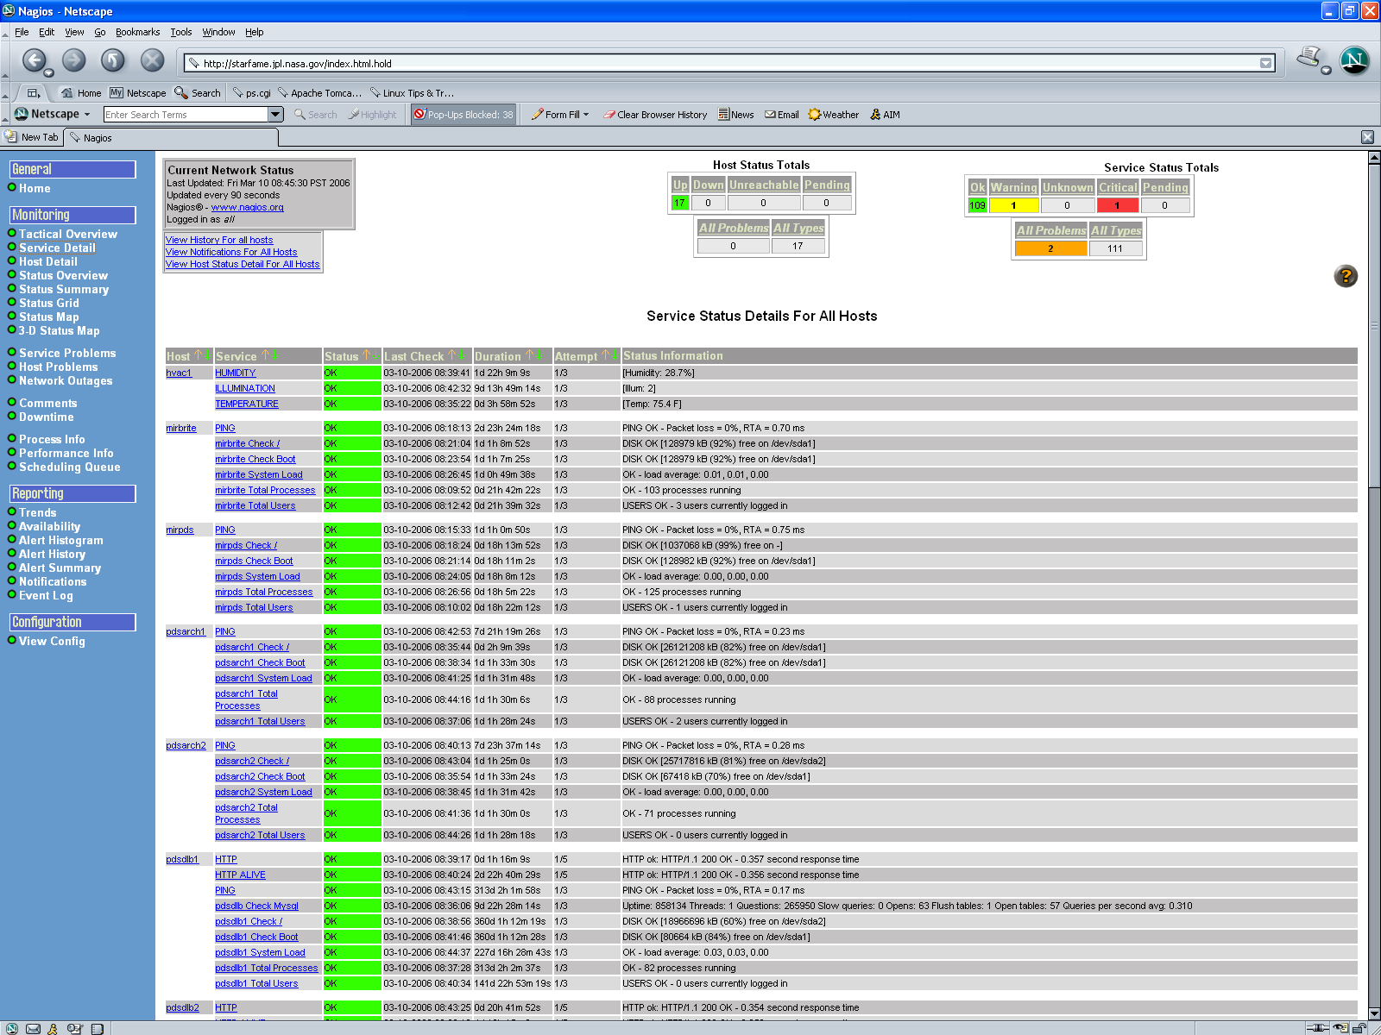

Planet Data System Mirror Site Firewall

To enforce security over communication between the operation systems and mirror site systems. We had applied all the firewall blockage to most of the ports, except the following:

Port 80 → PDS Apache Webpage on mirpds server.
Port 80 → PDS Apache Tomcat Webapps on mirbrite server.
Port 22 → security shell communication.
Port 888 → 3ware management utility.
Port 3306 → Sybase Database software.
Port 7577 → RMI registrary communication.
Port 25 → sendmail service.
Port 5666 → Nagios monitoring service.
Port 873 → rsync service.

APPENDIX A



